DPH-260AS泡罩包装机
DPH-260AS Blister Packing Machine

使用说明书
Operating manual
(S7-200 smart)

目 录
Content

1.安装前的准备事项 Preparations before installation 4
1.1. 注意事项Notes 4
1.2. 安装环境要求Installation environment requirements 5
2. 概 述Introduction 5
3. 主要技术参数及规格Main technical parameters and specifications 6
3.1. 运行参数Operating parameters 6
3.2. 包装材料Packing material 6
3.2.1. 塑料硬片(PVC)Plastic varnish (PVC) 6
3.2.2. 铝箔(PTP)Aluminum foil (PTP) 6
3.2.3. 硬铝 Hard aluminum 7
3.3. 主要配套部件Main supporting parts 7
3.4. 主要负载功率Main load power 7
3.5. 冷却水 Cooling water 8
3.6. 压缩空气Compressed air 8
3.7. 外形尺寸Outline dimensions 8
3.8. 重量 Weight 8
4. 主要机构及作用Principal organs and roles 9
4.1. 机身Fuselage; 9
4.2. 塑片（硬铝带）输送Plastic sheet (hard aluminum strip) conveying; 10
4.3. 塑片加热Plastic sheet heating 11
4.4. 成形器Shaper; 13
4.4.1. 铝塑成形器Aluminum plastic former 13
4.4.2. 铝铝成形器Aluminum-aluminum former 14
4.5. 加料器Feeder; 16
4.5.1. 盘式通用加料器Disc universal feeder 16
4.5.2. 胶囊有序排列加料器Capsule orderly arrange feeder 17
4.5.3. 圆盘振动加料器Disc vibrating feeder 20
4.6. 滚压热封Rolling heat seal; 20
4.7. 批号机构Batch number agency; 22
4.8. 切线机构Tangent mechanism; 23
4.9. 步进机构(输送铝塑、铝铝泡罩机构)Step mechanism (conveying aluminum plastic, aluminum blister mechanism) 23
4.9.1. 成形泡罩输送Formed blister conveying 23
4.9.2. 输送泡罩冲切Conveying blister punching 24
4.10. 冲切板块机构Punching plate mechanism 25
4.11. 传动机构Transmission mechanism 26
4.11.1. 成形器传动Shaper drive 27
4.11.2. 成型/冲切步进传动Forming/punching step drive 28
4.11.3. 滚模传动Roller drive 28
4.11.4. 冲压传动 Punching transmission 28
4.11.5. 对版传动Counterplate drive 28
5. 电气控制系统Electrical control system 30
5.1. 电气面板说明Electrical panel description 30
5.2. 触摸屏操作说明Operating manual for touch screen 31
5.2.1. 主登录界面Primary login interface 31
5.2.2. 温度设置Temperature settings 33
5.2.3. 温度校正Temperature correction 34
5.2.4. 延迟时间Delay time 34
5.2.5. 温度加热开关Temperature heating switch 35
5.2.6. 模具参数设置Mold Parameter Settings 36
5.2.7. 调试操作Debug operation 37
5.2.8. 生产操作Production operation 38
5.2.9. 剔废设置Discarding settings 40
5.2.10. 对板设置Opposite board settings 40
5.2.11. 故障显示Fault display 42
6. 气控系统Air control system 43
6.1. PVC塑片加热器顶升气缸控制Control of jacking cylinder for PVC Plastic sheet heater 43
6.2. 吹泡成型(铝塑)Blowing foam molding 43
6.3. 网纹辊升降控制Reticulated roll lift control 43
6.4. 剔废离合器控制Scrap clutch control 43
6.5. 气控原理图及调节方法Gas-control schematic diagram and adjust method 44
7. 润滑系统Lubrication system 46
7.1. 减速机变速机润滑Reducer lubrication 46
7.2. 冲模箱、加热板架、成形箱润滑Lubrication of die box, heating plate frame and forming box 47
7.3. 链轮链条齿轮及滑动件润滑Sprocket, chain gear and slider lubrication 47
7.4. 各封闭的滚动轴承润滑Lubrication of each closed rolling bearing 47
8. 水冷却系统Water cooling system 48
9. 对版系统Counterplate system 48
10. 视觉检测剔废系统Visual inspection and scrap removal system 50
11. 机器的使用和调整Use and adjustment of machines 51
11.1. 工艺流程Process flow 51
11.2. 操作程序Operating procedures 52
11.3. 模具更换Die replacement 55
11.4. 成型机构调整Adjustment of forming mechanism 57
11.5. 切模机构与主机的同步调整Synchronous adjustment of die cutting mechanism and main engine 58
11.6. 批号、切线位置调整Batch number, tangent position adjustment 58
11.7. 成型、热封加热温度调整Heat temperature adjustment of molding and heat seal 58
11.8. 切线与打印批号温度调整Tangent and print batch number temperature adjustment 59
11.9. 冷却水影响温度调整Effect of cooling water on temperature adjustment 59
11.10. 铝箔和薄膜模向位置调整Aluminum foil and film die alignment 60
12. 故障原因和排除Causes and troubleshooting 60
13. 安装和维护Installation and maintenance 61
13.1. 安装Installation 61
13.2. 维护Maintenance 62

安装前的准备事项 Preparations before installation

注意事项Notes
◇使用包装机前注意接地(PE),接地导线(4Ω以下,6mm²以上导线)。
Pay attention to grounding (PE), grounding leads (Less than 4Ω, and more than 6 mm ²) before using the packing machine.
◇ 使用包装机前检查冷却水系统、气动系统无渗漏。
Check the cooling water system before using the packing machine. There is no leakage in the pneumatic system.
◇ 使用包装机前注意给各润滑系统注入润滑油。
Pay attention to lubricating each lubrication system before using the packing machine.

安装环境要求Installation environment requirements
◇机器安放在水平的硬地面上，四周通畅。避免高温、潮湿、粉尘；避免日光直射；请勿受腐蚀性气体及油污的侵蚀。
The machine rests on a horizontal hard ground and is unobstructed. Avoid high temperature, humidity and dust; Avoid direct sunlight; Do not be corroded by corrosive gases and oil.
◇请在环境温度15℃-35℃，相对湿度40%-80%的条件下使用。
Please use at ambient temperature of 15 ℃-35 ℃ and relative humidity of 40%-80%.
◇安装本机器的车间要配置3 相5线制电源，另外必须配置一个PE接口，电源电压380V/50HZ，车间内在适当位置要安装一个40A空气断路器。
The workshop where this machine is installed shall be equipped with a 3-phase 5-wire power supply. In addition to a PE interface with a supply voltage of 380V/50HZ, and a 40A air circuit breaker shall be installed in the appropriate position in the workshop.
◇车间内要在适当位置安装一组给排水接口，排水口不能高出地面100mm，排水管路上禁止安装阀门。给水口要安装一只1/ 4”的截止阀，水压0.1-0.25Mpa。
A set of water supply and drainage interfaces shall be installed in proper places in the workshop. The drainage outlet shall not be 100 mm higher than the ground. Valves shall not be installed on the drainage pipelines. Install a 1/4 "stop valve at 0.1-0.25Mpa at the water supply port.
◇需气压0.7Mpa，洁净度0.5um的干燥压缩空气。
Dry compressed air with air pressure of 0.7Mpa and cleanliness of 0.5um is required.
◇车间面积大于3×4.5m2，开门大于1.1m。
The workshop area is more than 3 × 4.5m2, and the door opening is more than 1.1 m.

概 述Introduction
DPH-260AS型全自动高速泡罩包装机是一台高速滚板式铝塑/铝铝泡罩双用包装机，它既可以生产铝塑泡罩也可以生产铝铝泡罩。适用于多种规格的糖衣片、素片、胶囊、胶丸药品的包装，也可用于形状与上述药物相近的小五金．电子元件．医疗器械及食品的包装，具有密封可靠，携带使用方便，包装外形美观等特点。
DPH-260AS full-automatic high-speed blister packaging machine is a high-speed roller-plate aluminum-plastic/aluminum blister dual-purpose packaging machine, which can produce aluminum-plastic blister and aluminum-aluminum blister. It is suitable for the packaging of sugar-coated tablets, vegetarian tablets, capsules and capsules of various specifications, and also for the packaging of hardware, electronic components, medical devices and food, which are similar in shape to the drugs mentioned above. It has the characteristics of reliable sealing, convenient carrying and using, and beautiful packaging appearance.

主要技术参数及规格Main technical parameters and specifications

运行参数Operating parameters
◇硬片线速度 2.5-7m/min
Hard film linear velocity 2.5-7m/min
◇冲裁频率 20-120p/min(铝塑) 20-60p/min(铝铝)
Blanking frequency 20-120p/min (aluminum-plastic) 20-60p/min (aluminum-aluminum)
◇260成型面积(最大) 260×180×12mm(铝塑) 260×150×10mm(铝铝)
260 Moulding area (max.) 260 × 180 × 12 mm (aluminum-plastic) 260 × 150 × 10 mm (aluminum-aluminum)

包装材料Packing material

塑料硬片(PVC)Plastic varnish (PVC)
◇宽 度 范围：max260mm；mix180mm；
Width range: Max 260 mm; Mix180mm;
◇厚 度 范围：0.2-0.5 mm；标准：0.25 mm MAX：0.5 mm
Thickness range: 0.2-0.5 mm; Standard: 0.25 mm MAX: 0.5 mm
◇最大卷外径 MAX：φ400 mm
Maximum roll outer diameter MAX: φ400 mm
◇卷芯孔径 范围：φ70-80 mm
Core aperture range: φ70-80 mm

铝箔(PTP)Aluminum foil (PTP)
◇宽 度 范围：260机型max260mm；mix180mm；
Width range: 260 model max260mm; Mix180mm;
◇厚 度 范围：0.02-0.03 mm 标准：0.02 mm MAX：0.03 mm
Thickness range: 0.02-0.03 mm standard: 0.02 mm MAX: 0.03 mm
◇最大卷外径 MAX：φ250 mm
Maximum roll outer diameter MAX: φ250 mm
◇卷芯孔径 范围：φ70-80 mm
Core aperture range: φ70-80 mm

硬铝 Hard aluminum
◇宽 度 范围：260机型max260mm；mix160mm；
Width range: 260 model max260mm; Mix160mm;
◇厚 度 范围：0.15-0.2 mm
Thickness range: 0.15-0.2 mm
◇最大卷外径 MAX：φ400 mm
Maximum roll outer diameter MAX: φ400 mm
◇卷芯孔径 范围：φ70-80 mm
Core aperture range: φ70-80 mm

主要配套部件Main supporting parts
序号  No. | 名 称  Name | 功 率  Power | 数 量  Quantity | 品 牌  Brand | 备 注  Remarks
1 | 主电机  Main motor | 2.2kw | 1 | 德东  Dedong
2 | PVC送料电机  PVC feeding motor | 0.18Kw | 1 | 紫光  UNIS
3 | 伺服电机  Servo motor | 0.75kw | 2 | 松下  Panasonic
4 | 加热管260机型  Heat pipe 260 machine | 0.6kw | 6 | 自制  Homemade
5 | 加热板260机型  Heat plate 260 machine | 4.5kw | 2 | 自制  Homemade

主要负载功率Main load power
◇软化PVC加热板260机型 上板：4.5 kw 下板：4.5 kw
Softened PVC Heating Plate 260 Model Upper Plate: 4.5 kw lower plate: 4.5 kw
◇热封网辊加热260机型 加热管：0.6×6=3.6 kw
Heat-sealing roll heat 260 machine type heating pipe: 0.6 × 6 = 3.6 kw
◇热打印批号功率 加热管：0.5×2=1 kw
Hot-print batch number power heating pipe: 0.5 × 2 = 1 kw
◇热打撕裂线功率 加热管：0.5×2=1 kw
Hot tearing line power heating tube: 0.5 × 2 = 1 kw
◇伺服电机功率 1.5 kw/2Kw
Servo motor power 1.5 kw/2Kw
◇主电机功率 2.2Kw
Main motor power 2.2 Kw
◇总功率 20Kw
Total power 20Kw

冷却水 Cooling water
采用自循环冷却系统(冷水机)或者自来水。水压0.1-0.25Mpa，耗量60L/H。
Adopt self-circulating cooling system (chiller) or tap water. Water pressure 0.1-0.25 Mpa, consumption 60L/H.

压缩空气Compressed air
气压0.5-0.7 MPa 流量200 L/min
Air pressure 0.5-0.7 MPa Flow rate 200 L/min

外形尺寸Outline dimensions
长x宽x高：3140x950x1600 mm
Length x width x height: 3140x950x1600 mm

重量 Weight
总重：2300 kg
Gross weight: 2300 kg

主要机构及作用Principal organs and roles
本机主要由：1.机身；2.塑片（硬铝带）输送；3.加热器；4.成形器；5.加料器；6.电控系统；7.滚压热封；8.批号机构；9.切线机构；10.步进机构；11.冲切板块等部份组成。
This machine mainly consists of: 1. A fuselage; 2. Plastic sheet (hard aluminum strip) conveying; 3. Heater; 4. Shaper; 5. Feeder; 6. Electronic control system; 7. Rolling heat seal; 8. Batch number agency; 9. Tangent mechanism; 10. Stepping mechanism; 11. Punching plate and other parts of the composition.
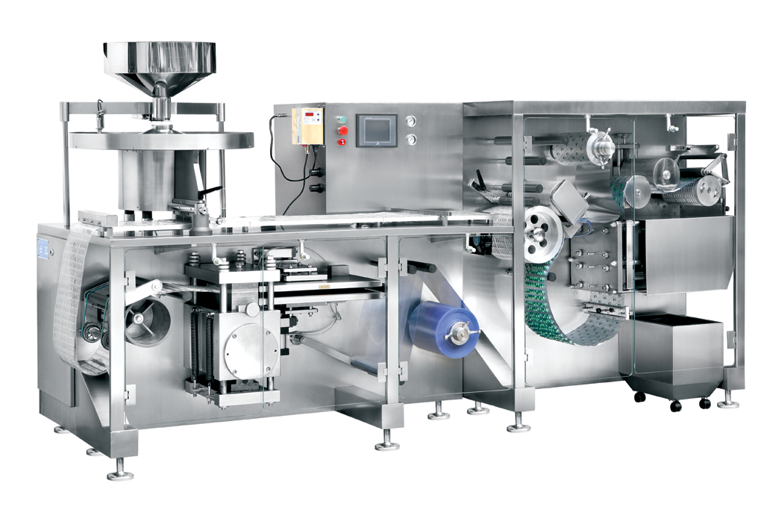
1 整体图
Overall drawing

机身Fuselage;
机身由机座和排坊为主体，用以支承各零部件，机座底面由17只可调底脚支承于地面，并用以调整机身的水平与垂直。由于机身较长，为了运输和安装于楼层之内，该机身分为前后二体，就位后用螺栓合并为整体，在合并时要注意校准水平。
The main body of the fuselage is the frame and the row house, which are used to support the components. The bottom surface of the frame is supported on the ground by 17 adjustable feet, and used to adjust the horizontal and vertical of the fuselage. Due to the long fuselage, the aircraft is located in front and rear for transportation and installation in the floor, and is bolted into a whole. During the merging, attention should be paid to the calibration level.

塑片（硬铝带）输送Plastic sheet (hard aluminum strip) conveying;
如图2，塑片输送机构主要由蜗轮减速电机1、转折辊8、 浮动辊9、光电开关11成一个自动送片机构。蜗轮轴与塑片（PVC）卷筒相连输展出塑片，浮动辊9受垂重力的作用下垂，将输展过来的塑片下拉，当浮动辊下降到下止点时，配重铁头上的钢片遮住了光电开关11（光电开关11相当于停止按钮），光电开关11的光信号通过控制线路转化为电信号，将电机切断电源，使电机停止转动，塑片此时也就暂停输送，另当塑片（PVC）被下工序（成形机构）拉取掉一定的量时也就是浮动辊上升到上止点时，光电开关又一次起动电动机，输送塑片起自动控制循环连续输送塑片的作用。
As shown in Figure 2, the sheet conveying mechanism is mainly composed of a worm gear reduction motor 1, a turning roller 8, a floating roller 9, and a photoelectric switch 11 as an automatic sheet conveying mechanism. The worm wheel shaft is connected with the PVC reel to transport and display the PVC sheet, the floating roller 9 is lowered by a vertical gravity, Pull down the conveyed plastic sheet, As that float roller descend to bottom dead center, the steel sheet on the counterweight iron head covers the photoswitch 11 (the photoswitch 11 corresponds to a stop key), the optical signal of the photoswitch 11 is converted into an electric signal by a control line, When the motor is cut off from the power supply to stop the motor from rotating, the conveying of the plastic sheet is suspended at this time, and when a certain amount of the plastic sheet (PVC) is pulled off by the next step (forming mechanism), that is, when the floating roller rises to the top dead center, the photoelectric switch starts the motor again, and the conveying of the plastic sheet plays the role of automatically controlling the continuous conveying of the plastic sheet.
图2
Figure 2

塑片加热Plastic sheet heating
图3
Figure 3
如图3，塑片加热机构的合理性对本机的成形合格率致关重要，本机构采用内埋电阻式加热板，气动控制其停机与工作时的闭合距离，支承座1支承主体，上支板2支承与带动上加热板作上下往复运动，由凸轮3作动力并与整机同步，上加热板4、下加热板5、下支承板6、和气缸7等构成一个完整的接触式加热系统。
As shown in Figure 3, the rationality of the sheet heating mechanism is important to the forming pass rate of the machine, The mechanism adopts an embedded resistive heating plate, pneumatically controls the closing distance between stopping and working, supports the main body of the support seat 1, supports and drives the upper heating plate to reciprocate up and down, is powered by a cam 3 and synchronizes with the whole machine, and forms a complete contact heating system including an upper heating plate 4, a lower heating plate 5, a lower supporting plate 6, and a cylinder 7.
◇硬铝采用冷拉成型，无需加热。
Duralumin is cold drawn without heating.

成形器Shaper;

铝塑成形器Aluminum plastic former
如图4，铝塑成形器由碟形弹簧1、上盖板2、成型模3、吹气模4、器体5、下盖板6、拉杆7、端盖8、拉簧9等组成。主电机传动带动器体内成形凸轮旋转运动，成形凸轮在拉簧的拉力作用下紧压在下盖板上的滚轮上，凸轮旋转带动下盖板上下移动，下盖板通过4条拉杆带动上盖板上下移动，使成型模和吹气模开启闭合。当模具闭合时由光电开关控制电磁阀接通吹入压缩空气，将成型模和吹气模之间软化的塑片成形成泡罩，当成型模和吹气模开启时，由下工序的牵引机构将已成形的泡罩带拉出并带动后排的软化的塑片进入模具内。
As shown in Figure 4, the aluminum molding apparatus is composed of a disc spring 1, an upper cover plate 2, a molding die 3, an air blow die 4, a device body 5, a lower cover plate 6, a pull rod 7, an end cover 8, a pull spring 9, and the like. The forming cam in the main motor driving device rotates, the forming cam is pressed against the roller on the lower cover plate under the pulling force of the pulling spring, the cam rotation drives the lower cover plate to move up and down, and the lower cover plate drives the upper cover plate to move up and down through four pull rods, so as to open and close the forming die and the blow die. As that mold is close, the solenoid valve controlled by the photoelectric switch is tur on to blow compressed air, the softened plastic sheet between the molding mold and the blow mold is formed into a blister, and when the molding mold and the blow mold are opened, the formed blister tape is pulled out by the traction mechanism in the next step and the softened plastic sheets in the rear row are driven into the mold.
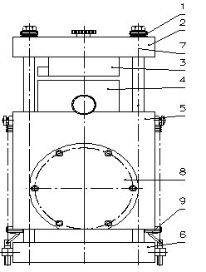
图4
Figure 4
◇成形器的四条拉杆的轴套是复合轴承，务必注意定时加油与清洁，每班加油二次，在机器运行过程中，注意检查模具安装螺丝，及四条拉杆的拼紧螺丝是否有松动情况，如有松动要及时用工具复原。
The axle sleeves of the four tie rods of the former are composite bearings. Always pay attention to regular refueling and cleaning, twice per shift. During the operation of the machine, pay attention to checking whether the mold mounting screws and the fastening screws of the four tie rods are loose. If they are loose, restore them with tools in time.

铝铝成形器Aluminum-aluminum former
如图5，铝铝成形器由上盖板1、凹模2、压模3、顶子4、滑块5、滑块座6、器体7、端盖8、拉簧9、拉杆10、下盖板11等组成。主电机传动带动器体内成形轴成形凸轮和拉伸凸轮旋转运动，成形凸轮在拉簧的拉力作用下紧压在下盖板上的滚轮上，凸轮旋转带动下盖板上下移动，下盖板通过4条拉杆带动上盖板上下移动，使成型模与压模开启闭合。拉伸凸轮在拉簧的拉力作用下紧压在滑块的滚轮上，拉伸凸轮带动装有顶子的滑块在滑块座内上下移动。当两模具闭合时，拉伸凸轮带动顶子向上顶，将成型模与压模之间的硬铝片冷拉成型，在拉簧的作用下，顶子快速下移退出到成型好的泡罩外，当两模具开启时，由下工序的牵引机构将已成形的泡罩拉出并带动后排的硬铝带进入模具内。
As shown in Figure 5, the aluminum-aluminum former is composed of an upper cover plate 1, a female die 2, a press die 3, a top 4, a slider 5, a slider seat 6, a body 7, an end cover 8, a tension spring 9, a tension rod 10, a lower cover plate 11, and the like. The forming cam and the stretching cam of the forming shaft in the main motor driving device rotate, the forming cam is pressed against the roller on the lower cover plate under the pulling force of the pulling spring, the cam rotation drives the lower cover plate to move up and down, and the lower cover plate drives the upper cover plate to move up and down through four pull rods, so as to open and close the forming die and the pressing die. The stretching cam is pressed against the roller of the slider under the pulling force of the stretching spring, and the stretching cam drives the slider with the top to move up and down in the slider seat. When the two molds are closed, the drawing cam drives the top to push up and cold-draw the hard aluminum sheet between the forming mold and the pressing mold. Under the action of the drawing spring, the top quickly moves down and exits the formed blister. When the two molds are opened, the drawing mechanism of the next step pulls out the formed blister and drives the rear row of hard aluminum strips into the mold.
图5
Figure 5

加料器Feeder;

盘式通用加料器Disc universal feeder
图6
Figure 6
如图6，该加料器主要由料斗1、分流刷2、行星盘刷3、料槽4和滚刷5等组成，料斗用于储存药品，开启闸板药品自行进入料槽，已形成泡罩的塑料薄膜将连续从料槽底部通过，因此，进入料槽的药品便撒落在薄膜上，后由四只行星运转轨迹的盘刷将药品刷入仰置的泡罩，滚刷绕水平轴按顺时针方向转动，置于加料器的出口，将薄膜上未能进入泡罩的药品，或刷入泡罩，或刷回加料器，加料器由单独的电机驱动。
As shown in Figure 6, that feeder is mainly compose of a hopper 1, a splitter brush 2, a planetary disk brush 3, a chute 4, a roller brush 5, and the like, A hopper is used to store medicine, opening the shutter and allowing the medicine to enter the material tank by itself, the blister-forming plastic film will continue to pass through the bottom of the tank, Therefore, the medicine entering the tank is scattered on the film, and then the medicine is brushed into the upturned blister by four planetary trajectory disk brushes, and the rolling brush is rotated clockwise around the horizontal axis and placed at the outlet of the feeder to brush the medicine on the film that cannot enter the blister, or into the blister or back to the feeder, which is driven by a separate motor.

胶囊有序排列加料器Capsule orderly arrange feeder
图7
Figure 7
如上图，本加料器由机架1、料斗5、设在机架1上的立柱9、沿立柱9往复运行的送囊梳6、送囊开关7与压囊梳8、设在机架1底座上的胶囊梳10，胶囊梳10的同一平面上相对应地增设推囊梳2，在机架1上设置转轴3，在转轴3上设置拨叉体4，该拨叉体4一端与所述的推囊梳2连接，另一端与送囊梳6连接。推囊梳2与胶囊梳10相对应的梳端形状呈W型触头。所述的拨叉体4为L型拨叉头。在所述的胶囊梳10下侧配置分流梳11，该分流梳11的梳间数量由包装的PVC塑料薄膜上的泡罩数量决定。本加料器，由主机引出的动力传送给转轴3，当转轴3按顺时针转动，L型拨叉头一端带动送囊梳6下行，在下行的过程中，送囊开关打开送囊梳的下端通道，在通道内的胶囊在自身重量作用下输出，与送囊梳同步下行的压囊梳8将上程序由推囊梳2推送到胶囊梳10输出端的胶囊压入分流梳11，并随之输送到PVC薄膜传送带已成型的泡罩内。与此同时，所述的L型拨叉头的另一端带动推囊梳2由右往左行，处于空行程阶段。同理，当转轴7按逆时针转动，L型拨叉一端由带动送囊梳6与压囊梳8上行，送囊开关复位堵住送囊梳6的下端通道，有效地控制了胶囊的输出，L型拨叉头的另一端则带动推囊梳2由左向右移动，当推囊梳2的W型触头尖端接触到胶囊帽体分界线时，胶囊将翻转，使胶囊帽的朝向为同一方向，即实现了变列无序为有序状态，其原理阐述如下：
As shown above, that feeder is compose of a frame 1, a hopper 5, a column 9 provided on the frame 1, a capsule feeding comb 6 reciprocate along the column 9, a capsule feeding switch 7 and a capsule pressing comb 8, a capsule comb 10 provided on the base of the frame 1, The capsule comb 10 is correspondingly provided with a push capsule comb 2 on the same plane, a rotating shaft 3 is arranged on the frame 1, and a shifting fork body 4 is arranged on the rotating shaft 3, wherein one end of the shifting fork body 4 is connected with the push capsule comb 2 and the other end is connected with the capsule feeding comb 6. The comb end shape of the push comb 2 corresponding to the capsule comb 10 is a W-shaped contact. The fork body 4 is an L-shaped fork head. A shunt comb 11 is arranged on the lower side of the capsule comb 10, and the number of comb rooms of the shunt comb 11 is determined by the number of blisters on the wrapped PVC plastic film. A feed, the power from the main engine is transmitted to the rotating shaft 3, As that shaft 3 rotate clockwise, At one end of that L-type shift fork head, In the downlink process, the blister feed switch opens the lower end channel of the blister feed comb, the capsule in the channel is output under its own weight, and the blister press comb 8, which is synchronized with the blister feed comb, pushes the capsule from the blister push comb 2 to the output end of the blister comb 10 into the shunt comb 11, and then transports the capsule into the formed blister cover of the PVC film conveyor belt. At the same time, the other end of the L-shaped fork head drives the pusher comb 2 from the right to the left and is in an empty stroke stage. As such, when that rotate shaft 7 is rotated counterclockwise, At one end of that L-type shift fork, the capsule feeding switch resets to block the lower end channel of the capsule feeding comb 6, The output of the capsule is effectively controlled, and the other end of the L-shaped shift fork drives the push comb 2 to move from left to right. When the tip of the W-shaped contact of the push comb 2 contacts the dividing line of the capsule cap body, the capsule will be turned over so that the orientation of the capsule cap is the same direction, that is, the column disorder is changed into an ordered state.
一、如图所示，当胶囊帽朝下从送囊梳6内排至胶囊梳10的梳孔上后，随着推囊梳2由左向右前行，其右端的W型触头尖端一触及胶囊帽体分界线，迫使胶囊 以分界线接触点为中心旋转，由于上端胶囊体直径略小于胶囊帽的直径，故在两端摩擦力差异作用下，胶囊势必按图4（a、b、c、d）所示顺时针旋转，胶囊则沿着推囊梳2的右行逐渐进入W型触头的下部空腔，最后呈水平状态推至压囊梳8正下方的胶囊梳10的输出端后，由压囊梳8在下一循环过程中压囊，输送到PVC薄膜传送带已成型的泡罩内，即可完成加料动作。
As shown in that figure, As that capsule cap is discharge downward from the inside of the capsule feeding comb 6 onto the comb hole of the capsule comb 10, As that pusher comb 2 move from left to right, As soon as that W-shape contact tip at the right end thereof touches the dividing line of the capsule cap body, forcing the capsule to rotate about the dividing line contact point, As that diameter of the upper capsule body is slightly small than the diameter of the capsule cap, As a result of that friction force difference between the two end, The capsule must be rotated clockwise as shown in Figure 4 (a, b, c, d), and the capsule is gradually entered into the lower cavity of the W-shaped contact along the right row of the push comb 2, finally pushed horizontally to the output end of the capsule comb 10 directly below the press comb 8, and then pressed by the press comb 8 in the next cycle to be conveyed into the formed blister of the PVC film conveyor belt.
二、如图所示，当胶囊帽朝上从送囊梳6内排至胶囊梳10的梳孔上后，随着推囊梳2由左向右前行，其右端的W型触头的尖端一触及胶囊帽体分界线，迫使胶囊以分界线接触点为中心旋转，由于下端胶囊体的直径略小于胶囊帽的直径，同理在两端摩擦力差异作用下，胶囊必然按图5（a、b、c、d）所示逆时针旋转，随着推囊梳2的继续右移，胶囊必将完全进入推囊梳2的上部空腔，最后呈水平状态输送到压囊梳8的正下方的胶囊梳10的输出端，等待下一循环的压囊动作。
As shown, As that capsule cap is discharge upwardly from the inside of the capsule feeding comb 6 onto the comb hole of the capsule comb 10, As that pusher comb 2 move from left to right, As soon as that tip of the W-shaped contact at its right end touch the dividing line of the capsule cap body, forcing the capsule to rotate about the dividing line contact point, As that diameter of the low end capsule body is slightly smaller than the diameter of the capsule cap, 5 (a, b, c, d). As that push comb 2 continues to move to the right, the capsule will completely ent the upper cavity of the push comb 2, and will finally be conveyed horizontally to the output end of the capsule comb 10 directly below the press comb 8, awaiting the next cycle of the press comb action.
综上所述两种情况，无论胶囊帽朝上或朝下，由于推囊梳的推囊动作，最终都能在胶囊梳的输出端得到胶囊体在前、胶囊帽在后的水平排列的胶囊有序输出，并由压囊梳压送到分流梳后呈水平状态输送到PVC薄膜传送带相应的泡罩内，起到有序排列加料的功效。
In both cases, Whether the capsule cap is upwards or downwards, due to the action of pushing the capsule comb, the capsules with the capsule body in front and the capsule cap in the rear arranged horizontally can be sequentially output at the output end of the capsule comb, and the capsules can be transported horizontally into the corresponding blister of the PVC film conveyor belt after being pressed into the shunt comb by the compression comb, thus having the effect of sequentially arranging feeding.

圆盘振动加料器Disc vibrating feeder
图8
Figure 8
如图8，其基本结构由料斗1、料盘2、电磁铁3、弹簧板4、底座5、料管6、喂料咀7、吸振座8及控制器组成，料盘受电磁铁电磁吸力和弹簧力作用下使从料斗流入料盘的药品绕着圆周向前爬行，当到达料管6的位置时掉入料管内，通过喂料咀7落到泡罩内，完成加料工作。
As shown in Figure 8, that basic structure is compose of a hopper 1, a tray 2, an electromagnet 3, a spring plate 4, a base 5, a material pipe 6, a feed nozzle 7, a vibration absorbing seat 8 and a control, Under the action of electromagnet electromagnetic attraction force and spring force, the medicine flowing into the material tray from the hopper climbs forward around the circumference, falls into the material tube 6 when it reaches the position of the material tube 6, falls into the blister through the feeding nozzle 7, and finishes the feeding work.
该加料器最为适应素片（浅弧片与平片）、胶囊。（该加料器由用户选配）
The feeder is most suitable for plain film (shallow arc film and flat film) and capsule. (The feeder is selected by the user)

滚压热封Rolling heat seal;
滚压热封主要由滚模1、热封辊2、摇摆支承架3、气缸4等组成（图9）。
The rolling heat seal is mainly composed of a rolling die 1, a heat seal roller 2, a rocking support frame 3, a cylinder 4, and the like (Figure 9).
图9
Figure 9
带有泡罩内装着药片的泡罩带与铝箔一起通过二辊之间时，受着压力与热能的作用，使铝箔上的热溶胶溶化粘合泡罩带，热封辊上刻有花纹，在压力的作用下将铝箔面压花使其热封更牢固并起到美化作用。
When the blister tape containing tablets in the blister and the aluminum foil pass through the two rolls together, under the action of pressure and heat energy, the thermal sol on the aluminum foil dissolves and adheres to the blister tape, and the heat sealing roller is engraved with patterns, and the aluminum foil surface is embossed under the action of pressure to make the heat sealing more firm and beautify.
滚模1由滚模前面的风机进行风冷，以保证及时冷却泡罩带保护泡罩不变形。
The roller mold 1 is air cooled by a fan in front of the roller mold to ensure timely cooling of the blister belt to protect the blister from deformation.
热封辊内装有6支不锈钢加热管，用以加热。6支不锈钢加热管受自动温控系统控制使热封辊保持恒温。
6 stainless steel heat pipes are arrange in that heat sealing roller for heating. Six stainless steel heating pipes are controlled by the automatic temperature control system to keep the heat seal roller at constant temperature.
摇摆支承架内通有冷却液起到保护轴承过热而涨死，并使支承架冷却，防止操作人员接触支承架时被烫伤。
Coolant is passed through the rocking support frame to protect the bearing from overheating and swelling to death, and to cool the support frame to prevent the operator from being scalded when touching the support frame.
气缸用以升降热封辊，热封辊对泡罩带与铝箔复合膜的压力由减压阀调节控制。
The air cylinder is used for lifting and lowering the heat seal roller, and the pressure of the heat seal roller on the blister tape and the aluminum foil composite film is regulated and controlled by the pressure reducing valve.

批号机构Batch number agency;
批号机构安装在冲模器体6上，它由固定板1、钢字2、脱料板3、承印板4、顶杆5、拉簧7、滚轮8、凸轮9等组成（图10）。当凸轮9旋转时（凸轮轴与冲模轴同步），在凸轮9与拉簧7的作用下，推动顶杆5使承印板4作横向往复运动。承印板4压向左边使固定板上的钢字2字迹压入泡罩带上完成硬打印工作。
The batch number mechanism is mounted on the die body 6, and is composed of a fixing plate 1, a steel character 2, a stripping plate 3, a printing plate 4, a ejector rod 5, a tension spring 7, a roller 8, a cam 9, and the like (Figure 10). When the cam 9 is rotated (the camshaft is synchronized with the die shaft), the ejector lever 5 is pushed to reciprocate the printing plate 4 laterally by the action of the cam 9 and the tension spring 7. The printing plate 4 is pressed to the left so that the steel 2 writing on the fixing plate is pressed into the blister tape for hard printing.
固定板内装有加热管，可加热进行钢字打印。
The fixing plate is equipped with heating pipe, which can be heated for steel character printing.
◇机器在工作时千万不要将手或硬物伸入2与4之间。
Never put your hand or hard object between 2 and 4 while the machine is working.
图10
Figure 10

切线机构Tangent mechanism;
如图11，切线机构另称压痕机构，切线机构由固定板1、可调承压板2、刀片3、移动板4、连杆5、偏心轴6、机体7等组成，当偏心轴旋转（偏心轴与冲模轴同步）带动连杆使移动板4作横向往复移动，当移动板压向左边时，安装在移动板4上的刀片3切入PVC/PTP，完成切线工作，切入PVC/PTP的深度由可调承压板2调节，切入的深度只可折断而不切断，检验切入深度的方法为取2-5板冲切成品，在任一断裂线处作支点，上下对折3-5次后能够撕拉成二片。
As shown in Figure 11, A tangent mechanism is also cal an indentation mechanism, A tangent mechanism is compose of a fixed plate, an adjustable pressure bearing plate, a blade, a moving plate, a connecting rod, an eccentric shaft, a body and that like, As that eccentric shaft rotate (the eccentric shaft is synchronized with the die shaft), When the moving plate is pressed to the left, the blade 3 installed on the moving plate 4 cuts into the PVC/PTP to finish the tangent work. The depth of cutting into the PVC/PTP is adjusted by the adjustable pressure bearing plate 2. The depth of cutting into the PVC/PTP can only be broken but not cut off. The method for checking the depth of cutting into the PVC/PTP is to take 2-5 plates as punching products.
图11
Figure 11

步进机构(输送铝塑、铝铝泡罩机构)Step mechanism (conveying aluminum plastic, aluminum blister mechanism)

成形泡罩输送Formed blister conveying
如图12，成形泡罩输送是将经成形器吹泡或冷冲成形的泡罩拉出一次成形长度,每次拉出的长度必须是非常准确一致的。步进模1表面刻有网纹，泡罩受同步带2的作用下贴合于步进模的圆柱上,同步带轮3安装在支架4上的偏心架上，调整其偏心量可改变同步带的松紧度。步进模受机内的伺服电机传动机构带动旋转一个角度时,即带动泡罩顺时针旋转,完成从右边拉入一组标准长度刚成形的泡罩,从左边送出一组与拉入相同长度的泡罩。
As shown in Figure 12, that shape blister delivery is to pull the blister blown or cold-stamped by the former out of the shape length once, and the length of each pull-out must be very accurate and consistent. The surface of the step die 1 is engraved with a mesh pattern, the blister is attached to the cylinder of the step die under the action of the synchronous belt 2, the synchronous belt pulley 3 is mounted on an eccentric frame on the bracket 4, and the eccentricity of the synchronous belt can be adjusted to change the tightness of the synchronous belt. When the stepping die is driven to rotate by the servomotor drive mechanism in the machine for an angle, the blister is driven to rotate clockwise, and a group of blisters with the newly formed standard length is pulled in from the right side, and a group of blisters with the same length is sent out from the left side.
图12Figure 12

输送泡罩冲切Conveying blister punching
图13
Figure 13
如图13，该机构为冲切工序的间歇进给机构。该机构安装在冲模上方，步进模1上开有与泡罩相吻合的凹坑，泡罩受压辊2.3的作用贴合于步进模的圆辊上,当受机内伺服电机的传动机构间歇带动时，步进模旋转一个角度带动泡罩进入冲模，让冲模冲切板块。该机构的动停时间必须与冲模的运动相协调。步进模由2只M8内六角螺钉固定在步进轴上的法兰上，法兰可作轴向移动调节，使之与冲模的纵向中心线相一致。
As shown in Figure 13, this mechanism is an intermittent feed mechanism of a punching process. The mechanism is mounted on the upper part of the die, the step die 1 is provided with a pit matching the blister, and the function of the blister pressure receiving roller 2.3 is fitted on the round roller of the step die. When driven intermittently by the transmission mechanism of the servo motor in the machine, the step die rotates by an angle to drive the blister into the die, so that the die punches the plate. The moving and stopping time of the mechanism must be coordinated with the movement of the die. The stepping die is fixed on the flange of the stepping shaft by two M8 hexagonal screws, and the flange can be adjusted for axial movement so as to conform to the longitudinal centerline of the die.

冲切板块机构Punching plate mechanism
如图14，该冲切板块机构由偏心轴1、连杆2、动模3、冲头4、刀片5、定模6、挡板7、出料嘴8．机体11等组成。
As shown in Figure 14, that die-cutting plate mechanism is compose of an eccentric shaft 1, a connecting rod 2, a moving die 3, a punch 4, a blade 5, a fixed die 6, a baffle 7, a discharge nozzle 8, a body 11, and the like.
当步进模旋转一个角度将一定长度的泡罩送入冲切模后，刚好动模3开始向右推动冲头4，将泡罩冲切并推入定模6的模腔内，并随之有序的推到出料嘴8上。冲切模下方装有切废料的刀片,与冲切模同步，当冲切模冲切版块时,它切断废边料。
When the stepping die rotates an angle to feed the blister of a certain length into the punching die, the moving die 3 starts to push the punch 4 to the right, punches and pushes the blister into the cavity of the fixed die 6, and then pushes the blister onto the discharge nozzle 8 in an orderly manner. A scrap cutting blade is arranged under the punching die, synchronized with the punching die, and cuts off the scrap side material when the punching die punches the plate.
图14
Figure 14

传动机构Transmission mechanism
如图15，本机的传动机构主传动由一台1.5KW，4极的电机带动一只弧齿锥齿轮减速机1、二只蜗轮减速机2、3和一只齿轮变速机4以及向各部份分配传输的齿轮、链轮链条组成，各往复运动机构由偏心轴或凸轮来完成。间歇步进传动由二台伺服电机5、6完成。对版传动由低速电机7与行星齿轮箱完成。下面将从动力输向各工作机构进行分述
As shown in Figure 15, the main drive mechanism of the machine is composed of a 1.5 KW, 4-pole motor driving a spiral bevel gear reducer 1, two worm gear reducers 2, 3 and a gear reducer 4, and gears and sprocket chains distributed and transmitted to each part. Each reciprocating mechanism is completed by an eccentric shaft or cam. The intermittent stepping drive is accomplished by two servo motors 5, 6. The alignment drive is performed by the low speed motor 7 and the planetary gear box. Hereinafter, the transmission of power to the working mechanisms will be described in detail
图15
Figure 15

成形器传动Shaper drive
由减速机1的低速输出轴通过一对齿轮带动成形器主轴(凸轮轴)旋转，主轴上装有一对曲线凸轮的外曲线面上，随着主轴的旋转滚轮贴凸轮从低位走向高位，又从高位走向低位。完成成形所需要的往复运动。
The main shaft (camshaft) of the former is driven to rotate by the low-speed output shaft of the reducer 1 through a pair of gears, and the outer curved surface of the main shaft is provided with a pair of curved cams, and with the rotation of the main shaft, the roller is attached to the cam from a low position to a high position, and from a high position to a low position. Reciprocating motion required to complete the forming.
在成形器主轴上装着一只向外传输链轮：传向加热器作分合动作。加热器座上装有一凸轮，受链条带动该凸轮顶动上加热板，使加热板作上下往复运动，使至加热板分合与成形器模具的分合同步。
An outward transmission sprocket is mounted on the main shaft of the former: Transmit to the heater for split-closing operation. A cam is mounted on the heater seat, and driven by a chain, the cam pushes the upper heating plate to reciprocate the heating plate up and down to separate the heating plate from the molds of the former.

成型/冲切步进传动Forming/punching step drive
成型/冲切步进采用伺服电机控制，伺服电机采用同步带传动给成型/冲切步进减速器的输入轴，输入轴通过齿轮减速传动给成型/冲切步进辊。
The forming/punching step is controlled by servo motor, which is driven by synchronous belt to the input shaft of forming/punching step reducer, and the input shaft is driven by gear reduction to the forming/punching step roller.

滚模传动Roller drive
减速机2与减速机1联动, 减速机2低速输出轴上装有一只链轮,通过链条带动滚模轴上的链轮,使滚模旋转。
The reducer 2 is linked with the reducer 1, and a sprocket is arranged on the low-speed output shaft of the reducer 2, and the sprocket on the roller shaft is driven by the chain to rotate the roller mold.

冲压传动 Punching transmission
该减速机3与减速机1、2联动同步，减速机3的输出轴直联到变速箱的输入轴上，变速机4有三档速度输出，它与成形器是1：1、1：2、1：3。那么就是说如果将变速手柄放在III=1：3，这样就会成形器动作一次，冲模要冲三次，I、II档类推。变速机的输出轴由联轴器与批号轴相连，冲模座里有冲模轴，压痕轴，批号轴。由齿轮互联，同步运作。
The reducer 3 is synchronized with the reducers 1, 2, the output shaft of the reducer 3 is directly connected to the input shaft of the transmission, and the transmission 4 has a third speed output, which is 1: 1, 1: 2, 1: 3 with the former. So if you put the gearshift handle on III=1: 3, then the shaper will act once, the die will be punched three times, I, II and so on. The output shaft of the gearbox is connected with the batch number shaft by a coupling, and the die seat is provided with the die shaft, the indentation shaft and the batch number shaft. Interconnected by gears, synchronized operation.

对版传动Counterplate drive
减速机2低速输出轴装有一链轮，通过链条与行星减速机太阳轮轴相连，低速电机7输出轴通过齿轮与行星减速机外齿圈相连，行星减速机行星架输出轴通过超越离合器、齿轮与网纹辊相连。
A low-speed output shaft of that reduce 2 is provided with a sprocket which is connecte with the sun shaft of the planetary reducer through a chain, the output shaft of the low-speed motor 7 is connected with the outer ring gear of the planetary reducer through a gear, and the output shaft of the planetary carrier of the planetary reducer is connecte with the mesh roller through an overoperating clutch and the gear.
综合以上所述，该机的传动比较简单，它是由一台电机带动一根联动轴，联动轴上有三台减速机，由三台减速机分配到三个工位，即1成形——2热封——3冲切。另外成型/冲切步进采用伺服电机传动。对版传动采用低速电面与减速电机联合传动。
According to the above, the transmission of the machine is relatively simple. It is driven by a motor with a linkage shaft. There are three reducers on the linkage shaft. The reducers are assigned to three stations, i.e., 1 shaping-2 heat sealing-3 punching. In addition, the forming/punching step adopts servo motor drive. The plate transmission adopts low-speed electric surface and deceleration motor combined transmission.

电气控制系统Electrical control system

本包装机的电源输入为三相五线制，380V/50Hz。
The power input of this packing machine is three-phase five-wire system, 380V/50Hz.
注意:
Note:
◇在接入本机ＱＦ断路器之前请安装一总闸刀（自动空气开关）
Install a master knife (automatic air switch) before connecting to the local QF circuit breaker.
◇另加一条截面积大于Φ6mm²的黄铜线接PE点,接地保护。
In addition, a brass wire with cross-sectional area larger than 6 mm 2 is connected with PE point for grounding protection.
◇维修机器时,务必将断路器拔向分状态,并将机器外的总闸刀拔向断开状态。
When repairing the machine, always pull the circuit breaker to the split state, and pull the main knife outside the machine to the open state.

电气面板说明Electrical panel description
图16
Figure 16
1为剔废显示器，机器配置有视觉检测剔废机构时才有该显示器，该显示器与视觉检测剔废控制器相联。
1 For a scrap removal display, the display is provided only when the machine is equipped with a visual detection scrap removal mechanism, and the display is connected with a visual detection scrap removal controller.
2为触摸屏，该触摸屏与PLC相联，操作人员通过触按触摸屏上的文字键来设置、操作机器。
2 is a touch screen, which is connected with a PLC, and an operator sets and operates the machine by touching and pressing a text key on the touch screen.
3为起动按钮(绿色)，开机前必须按下此按钮方可通电操作。
3 is start the key (green), you must press this key before starting the machine to power on.
4为急停按钮(红色蘑菇形)，如遇到紧急情况时可按此按钮，机器断电。
4 is the emergency stop key (red mushroom shape), which can be pressed in case of emergency and the machine is powered off.
5为蜂鸣器，当机器出现故障或其它情况时报警。
5 is a buzzer, alarming in case of machine failure or other conditions.

触摸屏操作说明Operating manual for touch screen
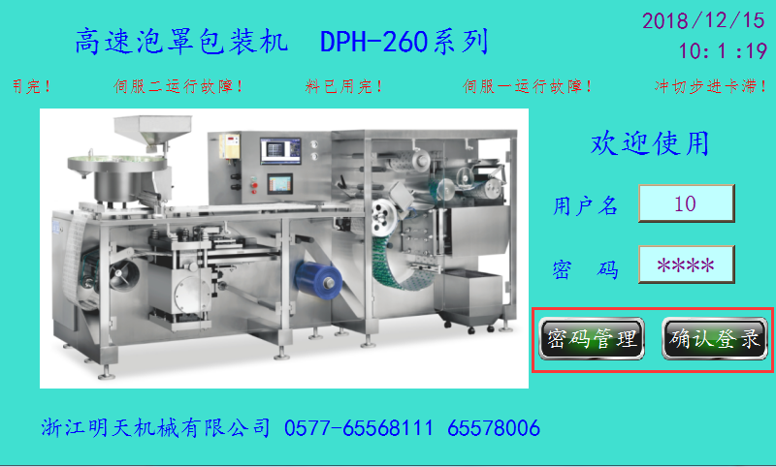

主登录界面Primary login interface
1.单击用户名和密码输入框，在弹出的对话框中输入用户名和密码；
1. Click the user name and password input box to enter the user name and password in the pop-up dialog box;
注1.若输入的账号和密码正确，则会显示[确认登录]按钮，单击该按钮后触摸屏跳转至[生产操作]界面。
Note 1. If the account number and password entered are correct, the Confirm Login key is displayed, and the touch screen jumps to the Production Operation interface after clicking the key.
注2.若输入的账号和密码不正确，[确认登录]按钮无法显示，系统也无法登录。
Note 2. If the account number and password entered are incorrect, the [Confirm Login] key cannot be displayed and the system cannot log in.
注3.本系统用户名无法修改，其中用户名1-7是操作员，8-9是调试员，10为管理员。
Note 3. The user name of this system cannot be modified, in which user name 1-7 is operator, 8-9 is debugger and 10 is administrator.
注4.管理员可以修改账号的密码。若登录时输入的是管理员账号，会同时显示[确认登录]和[密码管理]按钮。单击[密码管理]，在弹出的界面可修改本机所有账号的密码。
Note 4. Administrators can change the password for the account. If you enter an administrator account number at login, both the Confirm Login and Password Management keys are displayed. Click “Password Management” to open the interface to modify the passwords of all accounts in this machine.
注5.操作员账号可登录【生产操作】、【剔废对板】、【报警信息】、【生产记录】和【工艺流程】；调试员账号可登录【生产操作】、【剔废对板】、【报警信息】、【生产记录】、【工艺流程】和【温度设置】；管理员账号可登录所有界面，并可修改账号密码。
Note 5. Operator's account number can be logged in to "Production Operation", "Scrap Pair", "Alarm Information", "Production Record" and "Process Flow"; The debugger's account number can be logged in to Production Operation, Scrap and Wipe Opposite Board, Alarm Information, Production Record, Process Flow and Temperature Setting; The administrator account can log in to all interfaces and modify the account password.
序号  No. | 名称  Name | 操作员权限  Operator Permissions | 调试员权限  Debugger Permissions | 管理员权限  Administrator Permissions
1 | 生产操作  Production operation | √ | √ | √
2 | 剔废对板  Scrap counterplate | √ | √ | √
3 | 温度设置  Temperature settings | √ | √ | √
4 | 报警记录  Alarm record | √ | √ | √
5 | 时间、日期设置  Time, date settings | √ | √ | √
6 | 用户管理  User management | √ | √ | √
7 | 生产记录  Production records | √ | √ | √
8 | 工艺流程  Process flow | √ | √ | √
9 | 错误用户和密码  Bad user and password | 无法登录  Unable to sign in

温度设置Temperature settings
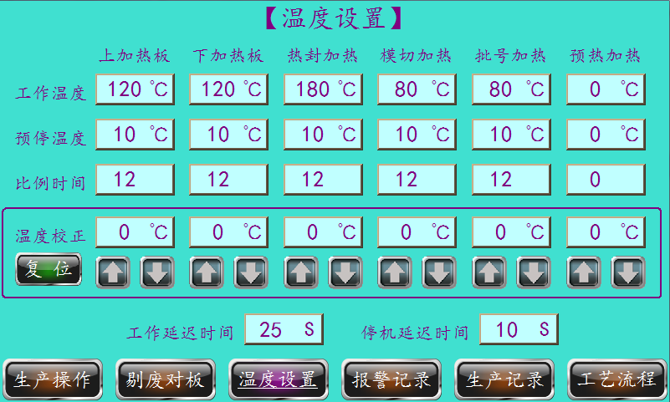
机器运行时，加热部位的加热元件一直加热直到达到[工作温度]才停止。加热元件一直加热，但由于热惯性的作用，到达设定的[工作温度]值时，温度还会继续上升。为防止加热超温，特设置[预停温度]和[比例时间]两个参数。
When the machine is operating, the heating element of the heating part is heated until it reaches the [operating temperature]. The heating element is heated all the time, but due to the thermal inertia, the temperature will continue to rise when the set [operating temperature] value is reached. In order to prevent heating overtemperature, two parameters, pre-stop temperature and proportional time, are set.
操作示例：[上加热板]温度设120℃，[预停温度]设10，[比例时间]设 12 。
Example operation: The [upper heating plate] temperature is set at 120℃, the [pre-stop temperature] is set at 10, and the [proportional time] is set at 12.
工作情况：[上加热板]加温打开后，加热元件一直加热到120℃-10℃=110℃时，开始进行间歇式加热：断开不加热12秒，通电加热1秒，反复进行，一直达到120℃使之恒温。
Work: After the [upper heating plate] is opened, the heating element is heated to 120-10 ℃ = 110℃, and intermittent heating is started: Disconnect without heating for 12 seconds, energize and heat for 1 second, and repeat until the temperature reaches 120 ℃.
注1.[工作温度]根据机器运行速度、PVC片材供应商的不同会有所差异。
Note 1. [Operating temperature] Depending on the speed of the machine, PVC sheet suppliers vary.
注2.[预停温度]、[比例时间]出厂一般会设置好，后期无需修改。
Note 2. [Pre-stop temperature], [Proportional time] will be set up in factory and need not be modified later.
注3.[工作温度]需要调试员或管理员权限才可修改。操作员无此权限。
Note 3. [Operating Temperature] requires debugger or administrator privileges to modify. Operator does not have this permission.

温度校正Temperature correction
当实测的温度与触摸屏显示的温度不一致时，可进行温度校正。
Temperature correction can be performed when the measured temperature does not coincide with the temperature displayed on the touch screen.
操作步骤
Operating Steps
1.将加热部位实测的温度与显示屏上的温度相对应，用[△]或[▽]进行加或减。随之对应的[温度校正]值会上升或下降。直到触摸屏上的[温度校正]值与实测温度相同为止。
1. Use [△] or [▽] to add or subtract the measured temperature at the heated position corresponding to the temperature on the display screen. The corresponding [temperature correction] value rises or falls. Until the [Temperature Correction] value on the touch screen is the same as the measured temperature.
3.如认为实测温度不确定，可触按[复位]键，重新由本机的测温系统进行自动测温。
3. If the measured temperature is considered uncertain, press [Reset] to re-measure the temperature automatically by the temperature measuring system of this machine.
注1.需专业人员和专用测温工具才能进行。
Note 1. Professionals and special temperature measuring tools are required.
注2.在出厂时温度已经过校正，不要随意更改。
Note 2. The temperature has been calibrated at the time of delivery. Do not change it at will.
注3.[温度校正]需要调试员或管理员权限才可操作。操作员无法修改。且需专业人士。
Note 3. [Temperature Correction] requires debugger or administrator privileges to operate. Operator cannot modify. And professionals are required.

延迟时间Delay time
1.[工作延迟时间]；按[运行]按钮后，机器主电机延时一段时间后开始运行，延时是因为网纹辊必须先压下和成型下加热板必须先上升后才能保证版块吹泡和热封的完整性。
1. [Operational delay time]; After pressing the [Run] key, the main motor of the machine starts to run after a period of time, because the reticulated roller must be pressed down and the heating plate must be raised before forming to ensure the integrity of the blowing bubble and heat seal of the plate.
2.[停机延迟时间]：按[停机]按钮后，主机停机后网纹辊廷迟升起时间。设置此时间主要是保障停机后由于惯性作用下会持续运行一段时间，避免出现网纹辊升起后滚模继续转动而造成泡罩带热合的不连续性
2. [Downtime delay]: After pressing the [Stop] key, the reticulated roll rises late after the main engine stops. The setting of this time is mainly to ensure the continuous operation for a period of time after shutdown due to inertia, so as to avoid the discontinuity of thermal closure of the blister belt caused by the continuous rotation of the reticulated roller after the hoisting of the reticulated roller

温度加热开关Temperature heating switch
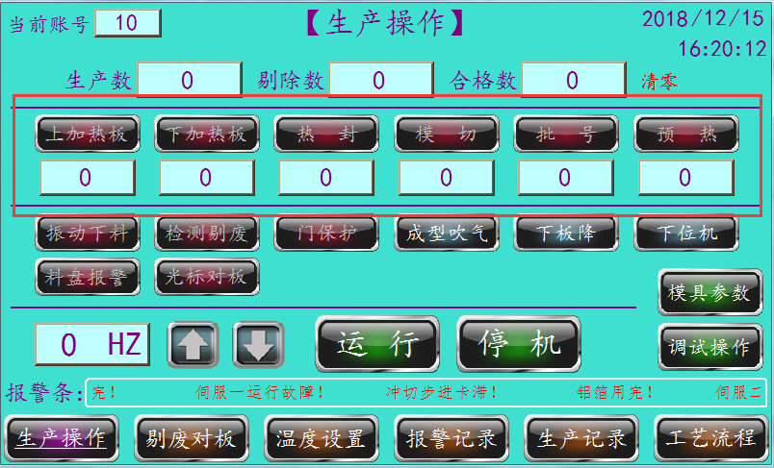
1.设置好温度之后，或者输入正确的账号密码登录之后，单击下方[生产操作]按钮。
1. After setting the temperature or logging in with the correct account password, click the [PRODUCTION ACTION] key below.
2.在[生产操作]界面，单击[上加热板]按钮，开启上加热板加热功能。
2. In the [Production Operation] interface, click the [Upper Heating Plate] key to turn on the upper heating plate heating function.
注1.若某工位加热功能未开启，则其按钮呈现灰色字体，浅色背景。若按钮字体为白色，且背景为高亮红色，则表示该部位加热功能以及开启。
Note 1. If the heating function of a certain station is not turned on, the keys will appear in gray font and light background. If the key font is white and the background is highlighted in red, it indicates that the part is heated and turned on.

模具参数设置Mold Parameter Settings
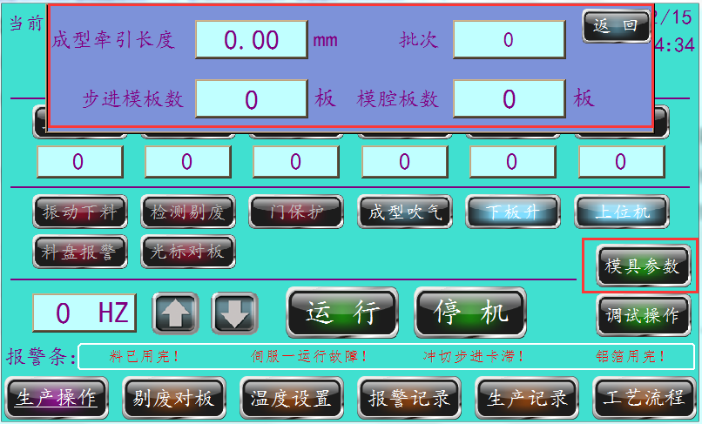
1.[生产操作]界面单击[模具参数]按钮。在弹出的对话框中输入要生产的模具参数。
1. Click the [Mold Parameters] key in the [Production Operation] interface. Enter the mold parameters to be produced in the pop-up dialog box.
2.[成型牵引长度]是指成型处一次牵引的距离。一般为（板块宽度）x（成型排数）+（废边）x（成型排数-1）。需在此基础上进行微调。
2. [Shaped traction length] means the distance of one traction at the forming site. Usually (width of plate) x (number of forming rows) + (scrap edge) x (number of forming rows-1). On this basis, fine-tuning is required.
3.[步进模板数]是指步进模一圈含有的板块排数。
3. [Number of Stepping Templates] refers to the number of rows of plates contained in a circle of the stepping die.
4.[批次]为记录本次生产的序列号。生产记录打印的时候会携带该序列号打印。
4. [Batch] is the No. for recording this production. This No. will be printed when the production record is printed.
5.[模腔板数]是指一次冲切多少板。
5. [Number of cavity plates] means how many plates are punched at a time.
注1.更换模具后，上述参数需要从新设定。
Note 1. After replacing the mold, the above parameters need to be set again.

调试操作Debug operation
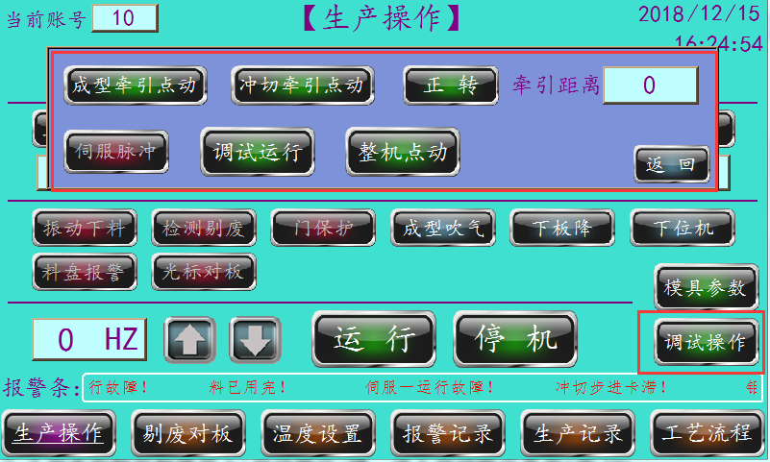
1.[生产操作]界面单击[调试操作]按钮。在弹出的对话框中可进行机器调试操作。
1. Click the Debug Operation key in the Production Operation interface. Machine debugging can be done in the pop-up dialog box.
2.[成型牵引点动]，长按该按钮，成型处会单独动作。
2. [Shape Drawing Point Move]. Press this key for a long time, and the shape will move separately.
3.[冲切牵引点动]，长按该按钮，冲切牵引处会单独动作。
3. [Punching and cutting traction point movement]. Press this key for a long time, and the punching and cutting traction place will be operated separately.
4.[正向/反向]，显示为[正向]时，单击[冲切牵引点动]步进模会顺时针转动。反之逆时针。
4. [Forward/Reverse], when shown as [Forward], click [Punch Draw Point Move] to rotate the step die clockwise. Counter-clockwise.
5.[牵引距离]，每次[冲切牵引点动]所移动的距离。
5. [Traction distance], the distance traveled by each [punch-cut traction point movement].
注1.[冲切牵引点动]、[正向/反向]、[牵引距离]这三者共同作用，可使板块对正模腔口。
Note 1. [Punching and shearing traction point movement], [forward/reverse direction] and [traction distance] can make the plate align with the cavity opening of the positive die.
4.[调试运行]，单击后，可成型出一段完整的泡带。
4. [Debug and Run]. After clicking, a complete bubble band can be formed.
5.[整机点动]，连续短按，机器各位置工位会缓慢变动。
5. [Whole machine is activated], press it successively for a short time, and the working position of each position of the machine will be changed slowly.
6.[伺服脉冲]，关闭该功能后，成型牵引和冲切牵引伺服将不工作。
6. [Servo Pulse]. When this function is turned off, the forming and punching traction servos will not work.

生产操作Production operation
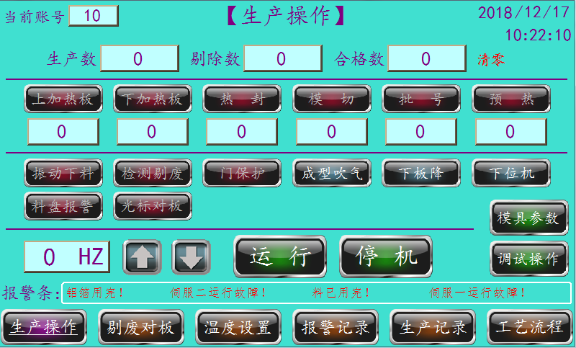
1.[振动下料]，控制振动下料器开关按钮。若激活该按钮，则振动下料器工作。
1. [Vibrating blanking], control the vibrating blanker switch key. If this key is activated, the vibrating feeder operates.
2.[检测剔废]，控制检测系统工作与否的按钮。若激活该按钮，则检测系统起作用。
2. [Detect and discard], a key that controls whether the detection system works or not. If this key is activated, the detection system works.
3.[门保护]，激活该按钮，门保护起作用，若生产过程中钢化门打开，机器会报警停机。
3. [Door protection]. Activate this key and the door protection will work. If the tempered door is opened during production, the machine will alarm to stop the machine.
4.[成型吹气]，激活该按钮，成型处一直吹气。一般是检查模具是否漏气。
4. [Molding Blowing] Activate this key and blow all the time at the molding site. Usually check whether the mold leaks.
5.[下板降/升]指下加热板所处状态。工作时处于[下板上]，传片时处于[下板降]。
5. [Lower Plate Down/Lift] refers to the state of the lower heating plate. Operate on [lower board up] and transfer film on [lower board down].
6.[下位机/上位机]，机器会根据界面上所设定的[上位机]与[下位机]进行上位停机和下位停机。所以按[停机]键后机器会继续运行至指定的位置停机。
6. [Lower/upper machine], the machine will be set on the interface according to the [Host] and [Host] for upper and lower downtime. So pressing the [Stop] key will continue the machine to the specified position to stop.
[下位机]是机器在停机后，成型模具处于闭合状态，它是为了机器停机后重新开机时泡罩的连续性。
[Lower machine] is the machine after shutdown, the mold is in a closed state, it is for the machine shutdown after restart blister continuity.
[上位机]是机器在停机后，成型模具处于开启状态，它是为了机器在调试时，PVC带能从模具中穿过。
[Host Machine] is when the machine stops and the molding die is in the open state, it is for the PVC tape to pass through the die when the machine is debugged.

7.[料盘报警]，激活该按钮，若料盘内连续180s无药片信号，机器会报警停机。一般在生产尾料的情况下才需关闭此功能。
7. [Disk Alarm] Activate this key. If there is no tablet signal in the disks for 180 seconds, the machine will alarm to stop the machine. This function is normally turned off only in the case of tailings.
8.[光标对板]，激活该按钮，光标对板功能起作用。
8. [Cursor to Plate], activate this key, and the cursor functions on the plate.
9.生产速度由△和▽控制。生产速度为HZ。若成型1次冲切3次，则冲切速度x 3。
9. Production speed is controlled by and. The production speed is HZ. If forming is performed once and punching is performed three times, the punching speed x 3.
10.[运行]、[停止]。该按钮控制机器的运行与停机。
10. [Run], [Stop]. This key controls the operation and shutdown of the machine.
11.[生产数]、[剔除数]、[合格数]反应的是机器生产信息。
11. [Production], [Elimination], [Qualification] reflect machine production information.
12.[清零]，长按该按钮，上述[生产数]、[剔除数]、[合格数]信息归零。
12. [Clear]. Press this key for a long time to return the above [production], [elimination] and [qualified] information to zero.

剔废设置Discarding settings
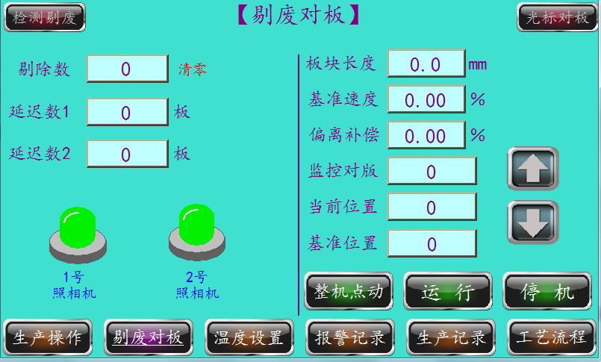

1.[延迟数]，视觉照相处离冲切模腔口的板块数。
1. [Delay number], the number of plates from the punching die cavity at the visual camera.
注1.若是错位排列，延迟数会相差1板。
Note 1. If misaligned, the number of delays will differ by 1 board.
注2.一冲有几板，一般就有几个延迟数需要设置。
Note 2. As soon as the punch has several boards, there are generally several delay numbers that need to be set.
注3.若某板被检测出为废板，则下方相机会显示红色。
Note 3. If a board is detected as scrap, the lower phase will be red.

对板设置Opposite board settings
1.[版块长度]是指沿PVC行走方向的板块规格，也是伺服开始为准的速度。
1. [Panel Length] means the panel size in the direction of travel of the PVC and the speed at which the servo starts.
2.[基准速度]是在版块长度的速度上再加百份比速度，最大百份之二十。该值设置时以监控对版数值来参考。该值加到监控对版数值往下减为止。再把该值往下减，减到监控对版数值往上加为止，再从这两个之间取个百份比。
2. [Base Speed] is the speed of the block length plus a specific speed of up to 20 percent. This value is set with reference to the monitor counterpart value. This value is added until the monitor counterpart value decreases. Subtract the value down until the monitor counterpart value is added up, and take a percentage between the two.
3[偏离补偿]是监控对版数值偏离的时候补偿，最大百分之二十。在对版下，监控对版数值高于基准位置数值的时候，偏离补偿百分比设起来一定要补偿到基准位置数值以下。在监控对版数值低于基准位置数值的时候，偏离补偿百分比是不起作用的，只有在监控对版数值高于基准位置数值的时候偏离补偿才起作用。只要监控对版数值可以补过来的前提下偏离补偿百分比设的越小越好。如果监控对版数值一直低于基准位置数值，就把对版关掉。如果还是往下掉就是铝箔光标太短。就把铝箔刹车刹紧一点，在不对版的前提下监控对版数值一定要一直往上加的，在对版下监控对版数值在基准位置数值上下跳动五、六十是正常的，只要不往一边一直加或一直减。
3 [Deviation Compensation] is the maximum compensation of 20 percent when monitoring the deviation of the counterplate value. In the counterpart, when the monitoring counterpart value is higher than the reference position value, the offset compensation percentage must be set to be compensated below the reference position value. The deviation compensation percentage does not work when the monitoring counterplate value is lower than the reference position value, but only when the monitoring counterplate value is higher than the reference position value. The smaller the offset compensation percentage is, the better as long as the monitoring counterpart value can be compensated. If the monitor counterplate value is consistently below the reference position value, turn off the counterplate. If it still falls, the aluminum foil cursor is too short. Just put the aluminum foil brake a little tighter, in the wrong version of the premise of monitoring the value of the counter-plate must be added up, under the counter-plate monitoring the value of the counter-plate jumping up and down in the reference position value of 50, 60 is normal, as long as not to one side has been added or decreased.
4.[基准位置]是铝箔光标和版块位置。在对版已经对上的话，铝箔光标不在版块下，铝箔光标往后就把基准位置数值减小，铝箔光标往前就把基准位置数值加大，具体减多少或加多少要看偏离多少而定。
4. [Reference position] is that position of the aluminum foil cursor and plate. Aluminum foil cursor is not under the plate, aluminum foil cursor will reduce the value of the reference position, aluminum foil cursor will increase the value of the reference position, the specific amount of decrease or increase depends on how much deviation.
5.[当前位置]是停机的铝箔光标位置。跟对版没关系，只是显示铝箔光标位置而已。
5. [Current position] is the stop foil cursor position. It has nothing to do with the counterpart, it just shows the position of the aluminum foil cursor.

故障显示Fault display
1.当气压过低时,显示屏将显示气压不足并停机,此时应检查气源是否正常供气及气路是否有漏气现象。如正常，请检查气压传感器是否损坏。
1. When the air pressure is too low, the display screen will show that the air pressure is insufficient and the machine will stop. At this time, check whether the air supply is normal and whether the air path is leaking. If normal, check the air pressure sensor for damage.
2.当加温部位某一路或一路以上温度失控超过极限温度时,机器将切断所有加热元件的电源并停机,显示屏显示超温部位名称及温度。此时请检查温度设置是否有错,如正确，请检查热电隅是否完好、可控硅是否击穿。
2. When the temperature of one or more heating parts is out of control and exceeds the limit temperature, the machine will cut off the power supply of all heating elements and stop the machine. The name and temperature of the overheated parts will be displayed on the display screen. Check the temperature setting for errors and, if correct, check that the thermoelectric corner is in good condition and that the thyristor is broken down.
3.PVC/硬铝带用完后,机器将停机并显示PVC/硬铝带已用完信息，此时请换上新卷PVC/硬铝带。
3. When the PVC/hardaluminum tape is used up, the machine will stop and display the information that the PVC/hardaluminum tape has been used up. Please replace the PVC/hardaluminum tape with a new roll.
4.铝箔用完后,机器将停机并显示铝箔已用完信息,此时请换上新卷铝箔。
4. After the aluminum foil is used up, the machine will stop and display the information that the aluminum foil has been used up. Please put on a new roll of aluminum foil at this time.
5.当填充物缺料时,面板上的蜂鸣器将响起,显示已缺料,但机器不停机,此时应尽快加料。
5. When the filling is short of material, the buzzer on the panel will ring to show that the material is short, but the machine will not stop, so the material should be added as soon as possible.
6.当成型或冲切伺服电面出现故障时。机器将停机并显示哪一只伺服电机故障。此时请参考伺服电机使用说明书。
6. In case of failure of the profiled or punching servo surface. The machine will stop and show which servo motor is faulty. Refer to the servo motor instruction manual at this time.

气控系统Air control system

PVC塑片加热器顶升气缸控制Control of jacking cylinder for PVC Plastic sheet heater
顶升气缸G1由二位五通电磁阀Y2控制，开机前，顶升气缸下降，上下加热板之间间距加大，方便PVC塑片穿过，开机后电磁阀Y2通电，顶升气缸向上推动下加热板上升，保障PVC塑片的加热。（硬铝冷成型无需加温，故顶升气缸不上升）
The jacking cylinder G1 is controlled by a two-position five-way solenoid valve Y2. Before starting the machine, the jacking cylinder is lowered, and the distance between the upper and lower heating plates is increased to facilitate the passage of PVC plastic sheets. After starting the machine, the solenoid valve Y2 is energized, and the jacking cylinder pushes the lower heating plate upward to ensure the heating of PVC plastic sheets. (The hard aluminum cold forming does not require heating, so the jacking cylinder does not rise)

吹泡成型(铝塑)Blowing foam molding
当成型器上下模（成型模与吹气模）闭合时在光电开关的控制下，电磁阀Y1通电将洁净的空气吹入成形模具，使已被加热软化的塑片形成泡罩。电磁阀Y1的通断与成型器的开合同步。吹泡压力一般为0.3~0.6MPa。
When the upper mold and the lower mold (molding mold and blowing mold) of the molding device are closed, under the control of the photoelectric switch, the solenoid valve Y1 is energized to blow clean air into the molding mold, so that the molded sheet which has been softened by heating forms a blister. The on-off of the solenoid valve Y1 is in step with the opening of the former. The blowing pressure is usually 0.3 ~ 0.6 MPa.

网纹辊升降控制Reticulated roll lift control
网纹辊的升降由压合气缸G3控制，气缸G3由二位五通电磁阀Y4控制，电磁阀Y4通电时，网纹辊压合在滚模上。其压力大小可由贮气罐上的调压阀调整。
The lifting and lowering of the reticulated roller is controlled by a pressing cylinder G3, which is controlled by a two-position five-way solenoid valve Y4. When the solenoid valve Y4 is energized, the reticulated roller is pressed against the roller die. The pressure can be adjusted by the pressure regulating valve on the gas storage tank.

剔废离合器控制Scrap clutch control
机器需配有视觉检测剔废，剔废离合器的开合由剔废气缸G4控制，剔废气缸G4由二位五通电磁阀Y5控制，电磁阀Y5由PLC控制。当电磁阀Y5通电时，冲切轴不运行，冲模不冲切版块。
The machine shall be equipped with visual inspection for scrapping, and the opening and closing of the scrapping clutch shall be controlled by a scrapping exhaust cylinder G4, which shall be controlled by a two-position five-way solenoid valve Y5, which shall be controlled by PLC. When the solenoid valve Y5 is energized, the punching shaft does not operate and the punching die does not punch the plate.

气控原理图及调节方法Gas-control schematic diagram and adjust method
如下图，L1是气源处理三联件，第一件是油水分离器，它的作用是对外来的压缩空气进行净化处理。第二件是减压阀，它的作用是调节压缩空气的压力，使之按机器需要的压力对机器供气（压力一般调节在0.4-0.6Mpa）。第三件是化油器，它的作用是将润滑油进行定量的雾化，送到各与之连接的滑动件（如柱塞式电磁阀、气缸）。调节方法是：用拇指和食指捏住字盘，顺时针旋转，当听到跳销跳动的一声卡嚓声时，是喷油量为最大，继续顺时针旋转，当临近于跳出时为喷油时最小，本机器的润滑油量一分钟约1滴，可以在化油器上方的观察帽上观察到。L2是气源处理二联件，它只对气源滤清和调压，工作原理与作用等同于三联件的第一、二件。L3是气源减压阀，它只是对网纹辊压合气缸的气源调节压力，保障泡罩带封合的密封性。G1、G2、G3依次为加热器顶升气缸、网纹辊压合气缸、剔废气缸。气缸G1的速度由节流阀A1和A2控制。要加快气缸速度时，可用手指逆时针旋动节流阀阀针手柄，要减速则相反，调节完毕之后，须拼紧阀针上的拼帽，如遇到锅到位时有较严重震动时，请用螺丝刀调节气缸上的阻尼针，顺时针旋转是减少以至关闭阻尼排气，逆时针旋转是加大排气，当减少阻尼排气可减轻震动，提高阻尼能力，同时也使到位减慢。气缸G2、G的速度由节流阀A3、A4控制，速度调节同上。
As shown below, L1 is a gas source process triplet, that first of which is an oil-water separator that purifies the compress air from the outside. The second is the pressure relief valve, which regulates the pressure of the compressed air so that it is supplied to the machine at the pressure required by the machine (the pressure is generally regulated at 0.4-0.6 Mpa). The third part is the carburetor, its role is to carry out a quantitative atomization of lubricating oil, to the sliders connected to it (such as plunger solenoid valves, cylinders). The adjustment method is: Hold the disc with your thumb and forefinger and rotate clockwise. When you hear a click of the jumper pin, the fuel injection amount is maximum. Continue to rotate clockwise. When you approach the jumper, the fuel injection amount is minimum. The lubricating oil amount of this machine is about 1 drop per minute and can be observed on the observation cap above the carburetor. L2 is the second component of air source treatment, it only filters and adjusts the pressure of air source, and its working principle and function are equal to the first and second components of the third component. L3 is the air source pressure reducing valve, which only adjusts the pressure of the air source of the reticulated roller compression cylinder to ensure the sealing of the blister belt. G1, G2 and G3 are that heat jacking cylinder, the mesh roll press cylinder and the exhaust gas removing cylinder in turn. The speed of cylinder G1 is controlled by throttle valves A1 and A2. To speed up the cylinder, "turn throttle needle handle counterclockwise with your fin, to slow down, After adjustment, the cap on the valve needle must be tightened. If there is serious vibration when the pot is in place, please use a screwdriver to adjust the damping needle on the cylinder. Clockwise rotation can reduce or even close the damping exhaust gas, and counterclockwise rotation can increase the exhaust gas. When reducing the damping exhaust gas, the vibration can be reduced, the damping capacity can be improved, and the position can be slowed down at the same time. The speed of the cylinders G2 and G is controlled by the throttle valves A3 and A4, and the speed adjustment is the same as above.

润滑系统Lubrication system

减速机变速机润滑Reducer lubrication
主传动系统有三只减速机和一只齿轮变速箱，旋开减速机上方红色的塑料油盖，并注入干净的汽车机油，至规定油位。注意：红色的塑料油盖径向有一通气用小孔，机器工作时请不要堵塞，如机器长时期停用，请将其堵塞。另外一只齿轮变速箱的加油方法，松开箱体上方的螺盖，注入汽车机油至视镜的中心点即可。
The main drive system consists of three reducers and a gearbox. Unscrew the red plastic oil cap on the reducer and fill it with clean vehicle oil to the specified level. Note: The red plastic oil cap has a small hole in the radial direction for ventilation. Do not plug the machine when it is working. If the machine is out of service for a long time, plug it. For another gear box, loosen the screw cap above the box and fill in the engine oil to the center of the mirror.
以上三只蜗轮减速机和一只变速箱，在初次使用半年换油一次，以后一年换油一次，要停用半年以上重新开机使用时要更换新油。
The above three worm gear reducers and one transmission shall change the oil once in half a year for the first time and once in the following year, and shall be replaced with new oil when the machine is stopped for more than half a year and restarted.
成型/冲切伺服减速器每1-2年大保养时更换钙基油脂一次。
Replace the calcium base grease every 1-2 years of heavy maintenance for the forming/punching servo reducer.

冲模箱、加热板架、成形箱润滑Lubrication of die box, heating plate frame and forming box
冲模箱、由一自动油泵集中供油润滑，每班开机时，油泵自动定时泵油；成形器、加热板架润滑需手工加油，并保持其开机前必须有油。
Die box, by an automatic oil pump centralized oil lubrication, each shift start-up, oil pump automatic timing pump oil; Lubrication of shapers and heating racks shall be manually oiled and maintained with oil prior to start-up.
◇开机时要检查各润滑点是否都有润滑油注入。
Check whether the lubricating oil is filled at each lubrication point when starting up the machine.

链轮链条齿轮及滑动件润滑Sprocket, chain gear and slider lubrication
机箱内开敞的链轮链条齿轮润滑，每日用手油枪喷注3-5滴普通机油。工作台面的开敞式滑动件每班喷注二次，每次喷1-2滴白油。
Lubricate the open sprocket chain gear in the chassis and spray 3-5 drops of common oil daily with a hand oil gun. Spray 1-2 drops of white oil into the open slider on the workbench twice per shift.

各封闭的滚动轴承润滑Lubrication of each closed rolling bearing
各封闭的滚动轴承及滑动轴承每1-2年大保养时更换钙基油脂一次。
Each closed rolling bearing and sliding bearing shall be replaced with calcium-based grease once every 1-2 years of major maintenance.

水冷却系统Water cooling system
该机的成形模、热封架需要循环水冷却，在机器的后侧下方装有进水口、进水阀门、排水口。冷却水（循环液或自来水，水温20℃±5℃）接入进水口，由进水阀门调节其给水量，水进入机器的冷却主管道由二通接头分流给各需冷却工位，第一道是进入上下成形模，用快换接头将水管连接上模，在上模内循环后排出接入下模，再从下模内循环后排出，进入排水主管道；第二道是通入热封机架，在热封机架内主要是冷却二端的轴承，同样在热封机内循环后排出进入排水道。
The forming die and heat seal frame of the machine need circulating water to cool, and the water inlet, water inlet valve and water drain are arranged under the rear side of the machine. Cooling water (circulating liquid or tap water, water temperature 20 ℃ ± 5 ℃) is connected to the water inlet, The water supply quantity is regulated by the water inlet valve, and the cooling main pipe of the water entering the machine is divided into different cooling stations by a two-way joint. The first path is to enter the upper and lower forming dies, connect the water pipes with the upper dies by a quick change joint, circulate in the upper dies, discharge the water pipes into the lower dies, circulate in the lower dies, and discharge the water pipes into the drainage main pipes. The second way is through the heat seal frame, in the heat seal frame is mainly cooling two-end bearings, also circulating in the heat seal machine after draining into the drainage channel.
机器使用一段时间后或停用一段时间该注意检查冷却系统水各接口和旋转密封是否有渗漏，如有渗漏请及时修复。
After using the machine for a period of time or disabling it for a period of time, pay attention to check whether there are any leaks in the water interfaces and rotary seals of the cooling system. If there are any leaks, repair them in time.

对版系统Counterplate system
对版是指每一版块的铝箔上只有唯一的完整的印刷体。本机对版系统由色标开关、铝箔调节器、伺服电机、齿轮组、单向轴承、旋转编码器、行星减速机组成。
Counterplate means that there is only one complete print on the aluminum foil of each plate. The system consists of color standard switch, aluminum foil adjuster, servo motor, gear set, one-way bearing, rotary encoder, planetary reducer.
对版的工作原理：印刷时特意将铝箔上两版面间距比成型好的版块间距略长，机器运行时，检测铝箔版面与成型版块间距大小。因铝箔版面长，则加速网纹辊使其圆周线速度比滚模圆周线速度快，在同样的时间内铝箔所走的长度比泡罩带长，调整补偿使铝箔版面与泡罩版面一致。
How the Version Works: During printing, the spacing between the two plates on the aluminum foil is specially longer than the spacing between the formed plates. When the machine is operating, the spacing between the aluminum foil and the formed plates is detected. As that layout of the aluminum foil is long, the speed of the circumferential line of the mesh roll is accelerated to be fast than the speed of the circumferential line of the rolling die, and the length of the aluminum foil is longer than the blister tape in the same time, and the layout of the aluminum foil and the blister tape are adjusted and compensated to be consistent.
它的功能是这样实现的：机器运行时，旋转编码器记录铝箔上的相邻两个色标段内滚模旋转的脉冲数n（角度）。PLC计算比较n与基准版数，若n大于基准版数，伺服电机加速带动网纹辊运行，此时网纹辊的圆周线速度比滚模圆周线速度快，纠正铝箔版面过长的问题。若其小于基准版数，伺服电机减速，此时单向轴承起作用，即网纹辊齿轮比伺服电机齿轮速度快。此时网纹辊的圆周线速度和滚模圆周线速度一致，铝箔与泡罩带等长运行。因印刷时铝箔版面间距比成型好的版块间距略长，一定时间后n大于基准版数，网纹辊又开如加速运行，这样往复循环达到补偿对版的目的。
Its functions are as follows: When the machine is operating, the rotary encoder records the number of pulses n (angle) of the rolling mode rotation in two adjacent color scale sections on the aluminum foil. If n is larger than the reference plate number, the servo motor accelerates the operation of the reticulated roller, and the circumferential speed of the reticulated roller is faster than the circumferential speed of the rolling die, thus correcting the problem of excessive length of the aluminum foil layout. If it is less than the reference plate number, the servo motor decelerates, at this time the unidirectional bearing works, that is, the reticulated roller gear is faster than the servo motor gear. At this time, the circumferential speed of the reticulated roller is the same as the circumferential speed of the rolling die, and the aluminum foil and the blister tape run at the same length. Because the spacing of the aluminum foil is slightly longer than the spacing of the formed plates, after a certain period of time, n is larger than the number of the reference plates, and the reticulation rollers are opened to speed up the operation, so that the purpose of compensating the opposite plates can be achieved through the reciprocating circulation.

视觉检测剔废系统Visual inspection and scrap removal system
视觉检测剔废系统由两部分组成：视觉检测系统和剔废系统。
The visual inspection and scrap removal system consists of two parts: Visual inspection system and scrap removal system.
视觉检测系统由相机、镜头、相机罩、光源、控制器等组成，它的工作原理是：开机运行时，PLC发拍照信号给相机，相机拍照将采集的图像数据发送给控制器，控制器计算比较其与标准图像的相似程度（操作者设定），再由控制器判断是否废版，如是废版发出一开关信号给PLC。（具体设置请参考视觉检测系统使用说书）
Visual inspection system is composed of camera, lens, camera cover, light source and controller. Its working principle is: During startup operation, the PLC sends a photograph signal to the camera, and the camera takes pictures and sends the collected image data to the controller. The controller calculates and compares the similarity with the standard image (set by the operator), and then the controller judges whether the scrapped plate is scrapped or not. If the scrapped plate is scrapped, the controller sends a switch signal to the PLC. (Please refer to the manual for use of the visual inspection system for specific settings)
剔废系统分离合器剔废和机械手剔废。
The scrapping system is divided into clutch scrapping and manipulator scrapping.
离合器剔废由剔废气缸、电磁阀、摆杆、离合器、花键、齿轮等组成。当PLC接收到视觉检测系统给出的废版信号后，廷迟一段时间（廷迟版数），接通电磁阀，剔废气缸动作脱开离合器，冲切模不动作，不冲切废版。废版掉入废料箱内，下一版为好版时，电磁阀断电，剔废气缸返回啮合离合器，冲切模继续冲切版块。
Clutch discarding consists of discarding exhaust gas cylinder, solenoid valve, swing rod, clutch, spline, gear and so on. When the PLC receives the scrap plate signal from the visual inspection system, it turns on the solenoid valve for a period of time (the number of scrap plates), disengages the clutch by removing the exhaust gas cylinder, and the punching die does not operate and the scrap plate is not punched. The scrap plate falls into the scrap box. When the next plate is a good one, the solenoid valve is powered off, the exhaust gas cylinder is returned to engage the clutch, and the punching die continues to punch the plate.
机械手剔废由机械手装置。主要含电磁阀、真空发生器、吸嘴、吸杆等组成。一般适用于联线。当PLC接收到视觉检测系统给出的废版信号后，廷迟一段时间（廷迟版数），吸嘴将板块从模腔口吸出，未达到输送线前将废板吹掉。废版掉入废料箱内。
Manipulator discard by manipulator device. Mainly consists of solenoid valve, vacuum generator, suction nozzle, suction rod and so on. Usually applied to online. When the PLC receives the scrap plate signal from the visual inspection system, the suction nozzle sucks the plate out of the mold cavity mouth for a period of time (the number of scrap plates), and blows the scrap plate off before reaching the conveying line. The scrap plate fell into the scrap bin.

机器的使用和调整Use and adjustment of machines

工艺流程Process flow
图34
Figure 34
本机的工艺流程，如图34所示，首先将PVC薄膜硬片从卷料上放展，PVC卷筒料架的里端装有蜗轮减速机和电动机，起动电动机，卷筒顺时针旋转，PVC即从卷筒上放卷展出，展出的PVC受摇臂的垂力作用下拉，当放卷一定长度，摇臂下拉到下止点时，摇臂支轴的里端上装有遮光挡片感应光电开关，光控信号切断电动机电源使电动机停止，暂停放展。当PVC被下工序抽拉了一定量之后，摇臂上升到上止点，摇臂支轴上的遮光挡片对光控起作用，使电动机起动，那么料卷又一次放展PVC，自动循环放料。
The process flow of this machine, As shown in figure 34, At first, that PVC film hard sheet is spread out from the roll material, the inner end of the PVC drum material rack is equipped with a worm gear reducer and an electric motor, Starting motor and reel rotate clockwise, PVC is unwound from reel and displayed. PVC is pulled down by the vertical force of rocker arm. When unwound for a certain length and the rocker arm is pulled down to bottom dead center, the inner end of rocker arm support shaft is equipped with light-shielding baffle inductive photoelectric switch, and the light-controlled signal cuts off the power supply of motor to stop the motor and suspend the unwinding. When the PVC is pumped in the next step, the rocker arm rises to the top dead center, and the light shielding plate on the rocker arm support shaft acts on the light control to start the motor, then the material roll is released again and the PVC is released automatically.
PVC受成形步进模的牵引，先经过上、下加热板的加热软化，再进入成形模具受压缩空气的吹拉，形成泡罩，泡罩带经过加料器下方，从加料平台上向前移动，泡罩从加料器下方经过时接受加料器充填物料。已接受加料的泡罩覆盖着铝箔PTP从热封滚模与热封网辊之间滚压通过，热封网辊受不锈钢加热管加温约240℃左右，热封网辊的高温使铝箔上的热溶胶溶化与PVC泡带的平面热熔粘合，热封滚模由一只散热风机冷却，使之保持常温，避免通过滚压热封时的泡罩变形。
The PVC is pulled by the forming step die, softened by the heating of the upper and lower heating plates, and then blown and pulled by the compressed air into the forming die to form a blister. The blister belt passes under the feeder and moves forward from the feeding platform. When the blister passes under the feeder, the feeder fills the blister. The blister covered with aluminum foil PTP that has been fed rolls through between the heat seal roller mold and the heat seal roller, The heat-sealing roller is heated by a stainless steel heating pipe at about 240 ℃. The high temperature of the heat-sealing roller melts the hot sol on the aluminum foil and fuses with the flat surface of the PVC foam belt. The heat-sealing roller mold is cooled by a heat dissipating fan to keep the heat-sealing roller at normal temperature and avoid the deformation of the foam cover during rolling heat-sealing.
已热封上PTP的泡带经过打印装置打印批号，再通过压痕切线装置压线（如果需要压线）在受冲切步进模的牵送下进入成品冲切模具，冲切模具把泡带冲切成成品板块并有序的顺送到出料嘴上，边角废料被下边的废边料切刀切成碎片落到废料小车里边。
The hot-sealed PTP blister tape prints the batch number through the printing device, At that same time, press lines (if press lines are needed) of the indentation tangent device enter the finished punching die under the pull of the punching step die, the punching die punches the bubble belt into finished plates and sequentially sends the bubble belt to the discharge nozzle, and the corner waste is cut into pieces by the scrap edge material cutting knife on the lower side and dropped into the inside of the scrap trolley.

操作程序Operating procedures
1、清理机器各部位及机器周围的地面。
1. Clean up all parts of the machine and the ground around the machine.
2、给机器加注润滑油。
2. Fill the machine with lubricating oil.
3、检查电源及接线是否符合本机要求。
3. Check whether the power supply and wiring meet the requirements of the machine.
4、检验接地PE保护是否符合要求。
4. Check whether the grounding PE protection meets the requirements.
5、检查给水、排水系统是否符合要求。（给水压力大于0.15Mpa，排水管路畅通无阻、无截止阀）
5. Check whether the water supply and drainage systems meet the requirements. (The feed water pressure is greater than 0.15 Mpa, the drain pipe is unobstructed and has no stop valve)
6、检查提供给本机压缩空气源是否符合要求（压力大于0.6Mpa流量大于0.3M3/min）
6. Check whether the compressed air source supplied to the machine meets the requirements (pressure greater than 0.6 Mpa, flow greater than 0.3 M3/min).
7、打开机器后面的矮门，用手转动电机至减速机之间的传动长轴确认机器各传动部份正常并无卡滞现象。
7. Open the low door at the back of the machine, and turn the motor to the drive shaft between the reducer by hand to confirm that all the drive parts of the machine are normal without jamming.
8、合上电源空气开关，按一下机器起动按钮，触摸屏通电显示。
8. Close the power supply air switch, press the machine start key, and the touch screen will be energized for display.
9、在触摸屏时给各加热器设定温度值、预停温度、加热比例时间等参数，触按各加热器按键，给各加热器预热。
9. Set temperature value, pre-stop temperature, heating proportion time and other parameters for each heater when touching the touch screen, and press the key of each heater to preheat each heater.
a、上下加热板温度值的设定
A. Setting the temperature value of the upper and lower heating plates
PVC塑片的成形温度范围很宽，理论成形温度为90-180℃，由于PVC塑片的产地（制造商）不同，PVC最佳软化成形温度不同，而且机器运行速度、环境温度、空气气流流速、冷却水温度、塑片厚度等因素也是密切相关的，一般上下加热板的设定值为130℃左右。实际运行时按吹泡成形的泡罩质量进行调整温度，
The forming temperature range of PVC sheet is very wide, and the theoretical forming temperature is 90-180 ℃. The optimum softening forming temperature of PVC sheet is different because of the different producing area (manufacturer) of PVC sheet, and the factors such as machine operating speed, ambient temperature, air flow rate, cooling water temperature and sheet thickness are closely related. Generally, the setting value of upper and lower heating plates is about 130 ℃. In actual operation, the temperature is adjusted according to the blister mass formed by blowing,
调整温度基本原则如下：
The basic principles for adjusting the temperature are as follows:
PVC硬、厚，温度高；PVC软、薄，温度低
PVC hard, thick, high temperature; PVC soft, thin, low temperature
机器速度快，温度高；机器速度慢，温度低
Machine speed, high temperature; Slow machine speed, low temperature
环境温度低，气流流速快，冷却水温度低，温度高，否则则相反。
Low ambient temperature, fast airflow, low cooling water temperature, high temperature, otherwise the opposite.
◇机器超低速运行时(成形速度23次/分以下)，反而温度要稍作调高，因为机器太慢，被牵引的PVC片材在牵引过程中冷却降温而达不到成形所需的软化温度。
When the machine is operating at ultra-low speed (forming speed below 23 bpm), the temperature should be slightly increased, because the machine is too slow, and the PVC sheet being drawn cannot reach the softening temperature required for forming due to cooling and cooling during the drawing process.
b、网纹辊温度设定值铝箔PTP热熔胶的熔化温度有密切关系，由于各制造商的铝箔PTP热熔胶温度相差较大，热熔温度互差大约50℃。同时受机器速度等其他因素影响，一般网纹辊温度设定值为210℃左右。实际运行时泡罩热封密封质量进行调整温度。
B. The melting temperature of the aluminum foil PTP hot melt adhesive is closely related to the setting value of the reticulated roll temperature. Because the temperature of the aluminum foil PTP hot melt adhesive of each manufacturer is quite different, the difference of the hot melt temperature is about 50 ℃. At the same time by the machine speed and other factors, the general reticulation roller temperature setting value is about 210 ℃. Actual operation of the blister heat seal seal quality to adjust the temperature.
其本原则：热封温度=
Its underlying principles: Heat seal temperature =

◇密封质量达到合格，设定温度和网辊压力尽可能低。
The sealing quality is up to standard, and the set temperature and the pressure of the net roll are as low as possible.
10、打开供水阀
10. Open the water supply valve
11、打开供气阀（见照片4），并调节压力0.4Mpa左右(压力调节范围0.35-0.6Mpa)
11. Open the air supply valve (see Photo 4) and adjust the pressure around 0.4 Mpa (pressure adjustment range: 0.35-0.6 Mpa)
◇泡罩质量合格，压力尽量调低。
The blister is qualified and the pressure should be lowered as far as possible.
12、首次使用时，检查电、水、气、油系统无泄漏现象，按加料平台下的起动按钮机器空载运行30min，观察各部件是否运行正常。
12. During the first use, check whether the electric, water, gas and oil systems are free of leakage. Press the start key under the feeding platform to run the machine without load for 30 minutes, and observe whether the components are operating normally.
13、剪一段PVC和PTP放到滚模与网纹辊之间，点动触摸屏上的[工作]键使主机启动后立即停止，观察热封网辊压下与提升是否正常。
13. Cut a section of PVC and PTP and put them between the rolling die and the reticulation roller. Click the [Work] key on the touch screen to stop the main machine immediately after starting, and observe whether the hot sealing roller is pressed down and lifted normally.
14、放置PVC薄膜，穿过成形模具，将其插入成形步进模各同步带之间，机器在目标速度下运行（主机显示30Hz）机器即开始成形泡罩带，制得的泡罩带长度约5m长，够按工艺流程图的路径通入冲切模中。
14. Place that PVC film through the forming die, insert it between the synchronous belts of the forming step die, and the machine starts to form the blister belt at the target speed (the main machine displays 30Hz), and the length of the blister belt produced is about 5m, which is long enough to pass into the die according to the path of the process flow chart.
15、将铝箔PTP平铺于热封滚模和热封辊。
15. Tile the aluminum foil PTP on the heat sealing roller die and the heat sealing roller.
16、起动加料器，视本机本批药物配何种加料器（请参阅4.5加料器）。
16. Start the feeder, depending on which feeder is used for this batch of medicine (see 4.5 Feeder).
17、调节冷却水流量，保持成形模具工作温度在（40℃-50℃），在运行一定时间内再多次调控。
17. Adjust that flow rate of cooling water, keeping the working temperature of the forming die in the range of (40℃-50℃), and adjusting and controlling the flow rate for a plurality of time within a certain period of operation.
18、起动主机运行，并慢慢提速，直到机器速度开到最高速的的80%。
18. Start the main engine operation and slowly increase the speed until the machine speed reaches 80% of the highest speed.
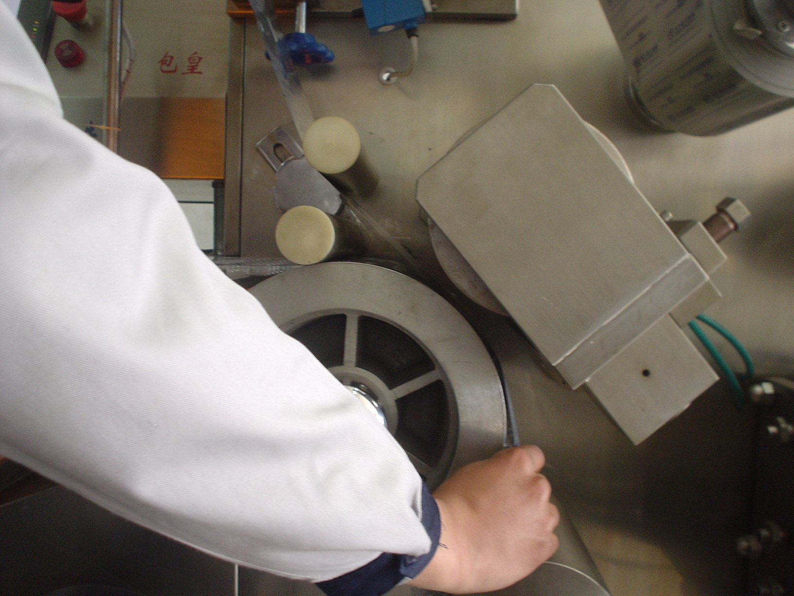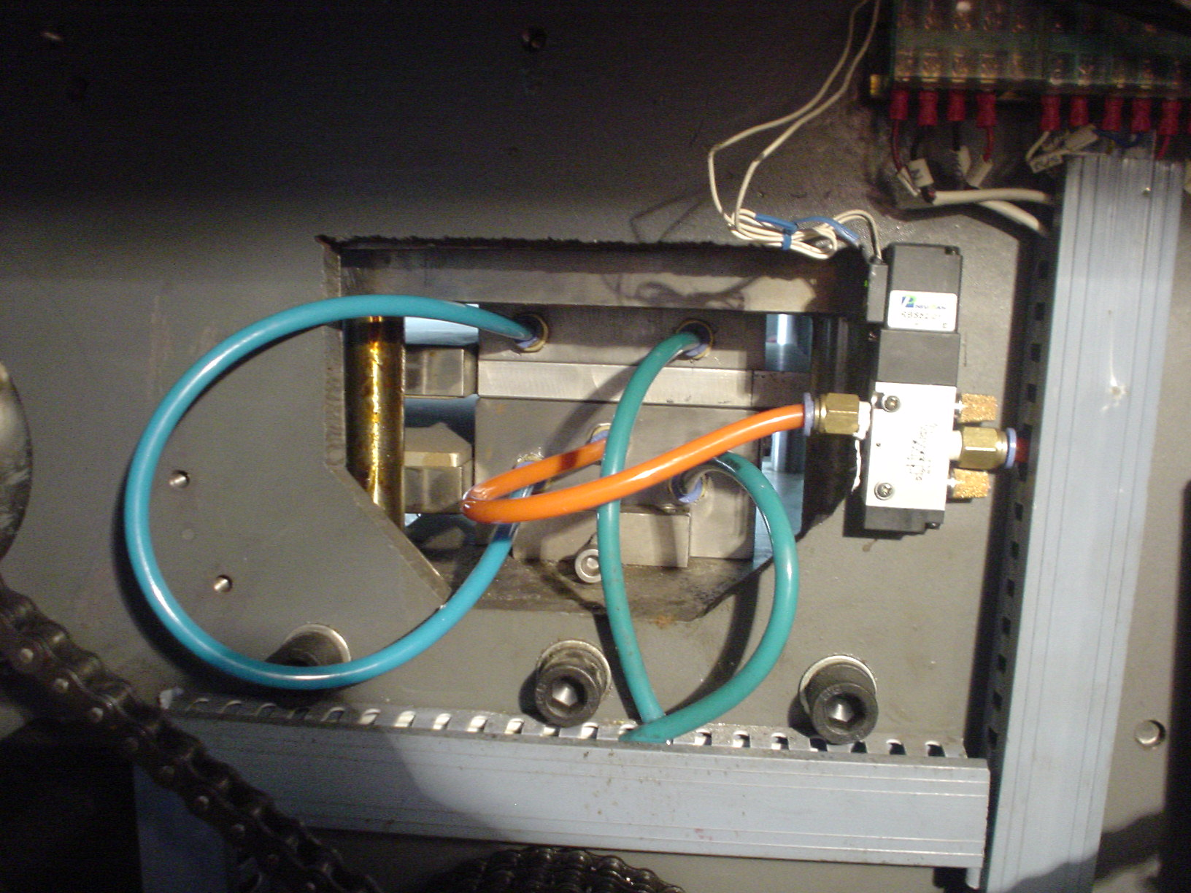
图7 图8
Figure 7 Figure 8

模具更换Die replacement
1、关好进气、进水阀；
1. Close the intake and water intake valves;
2、成形模与吹气模的更换：
2. Replacement of forming die and blowing die:
打开机身后方的矮门，用右手拨拉套在模具上的快换接头，将全部接头拨下（照片8）。请注意不要让遗留于管路内的水滴甩在机器部件上，特别是电器上。若有水滴于机件，请用干布擦干。逆时针旋转成形模架上的二只滚花小手轮，抽出成形模，再松开吹气模紧定螺丝，取出吹气模，用相对以上相反的动作，装入更换的模具，新模具的宽度如比老模具的宽度宽，请调节上下加热板向后移动，如新模具的宽度比老模具窄，请调节上下加热板向前移动，加热板靠向模具的端面间隙1mm为宜。接回气管、水管。
Open the low door at the rear of the fuselage, pull the quick-change connectors on the mold with your right hand and pull all connectors off (Photo 8). Please take care not to let the water droplets left in the pipeline fall on the machine parts, especially on the electrical appliances. If there is any water dripping on the machine, please dry it with a dry cloth. Rotate the two knurled handwheels on the forming die holder counterclockwise, drawing out the forming die, Then loosen the tightening screw of the blow mold, take out the blow mold, and use the opposite action to install the replacement mold. If the width of the new mold is wider than that of the old mold, please adjust the upper and lower heating plates to move backward. If the width of the new mold is narrower than that of the old mold, please adjust the upper and lower heating plates to move forward. The gap between the heating plates and the end face of the mold should be 1mm. Connect the air pipe and water pipe.
3、换装热封滚模，
3. Replace that heat sealing roll die,
用上模工具顺时针松开滚模端面中间的固定螺母，另用专用卸模工具慢慢拉出模具约20mm后，用双手护抱滚模拉出。装回新模具时请先将模具清洁干净，主轴上并涂少许机油，装上之后，用原固定螺母丝旋紧。
Loosen the retaining nut in the middle of the end face of the roller mold clockwise with the upper mold tool, and slowly pull out the mold with the special mold unloading tool for approx. 20mm. Then pull out the roller mold with both hands. When fitting the new mold, please clean the mold first, coat the spindle with a little oil, and then tighten it with the original fixing nut wire.
4、换装冲切步进模
4. Changing the die for punching and cutting step-by-step
旋开步进模二只M8的端面固定螺钉，用双手护抱步进模外圆柱面，均匀而平稳的拉出步进模；将新模内孔壁擦试干净，并涂上少许机油，均匀而平稳的推装上去。端面用二只M8的螺钉固定。
Unscrew the two M8 end face fixing screws of the step die, hold the outer cylindrical surface of the step die with both hands, and evenly and steadily pull out the step die; Wipe off the inner hole wall of the new mold and coat with a little oil. Push on evenly and smoothly. Fix the end face with two M8 screws.
5、如果平台导轨也需要更换，请拿出老导轨，换上新导轨。
5. If the platform guide rail also needs to be replaced, please take out the old guide rail and replace it with a new guide rail.
6、导轮拼装，找出适合的导轮，调装适合新模具的要求。
6. Assemble the guide wheel, find out the suitable guide wheel, and adjust and install it to meet the requirements of the new mold.
7、换装冲切模；冲切模是刀具、刀口很锋利不要伤割人身，特别是手指，也不能用硬物碰伤刀刃而损坏模具。更换步骤如下：
7. Reassembling die; Punching die is a tool, the knife edge is very sharp do not cut people, especially fingers, also cannot use hard objects to hurt the blade and damage the mold. The replacement procedure is as follows:
（1）取下模架罩；（2）取出连杆销；（3）松下四只冲模固定螺帽；（4）用柄（或橡胶锤）轻击模腔；（5）用厚布包裹模具；（6）戴上防护手指套；（7）抱拉模具下机。装上新冲切模，按上述步骤返回安装。
(1) Remove the cover of the mold holder; (2) Take out the connecting rod pin; (3) Panasonic four die fixing nuts; (4) Tapping the mold cavity lightly with a handle (or rubber hammer); (5) wrapping the mould with thick cloth; (6) Wear protective finger cover; (7) Clamping and pulling dies off the machine. Install the new die and return to installation as described above.
8、更换批号、压线零件
8. Replace the batch number and wire pressing parts.
旋开批号脱料板上两只螺栓，取出脱料板，旋开弹簧压条上的两只螺栓，将弹簧压条转至向上方向，再旋松批号固定座的两只顶紧螺钉、取出批号座。将其钢字换好锁好，按按上述步骤返回安装。
Unscrew the two bolts on the batch number stripping plate, take out the stripping plate, unscrew the two bolts on the spring pressure strip, turn the spring pressure strip to the upward direction, and then unscrew the two jacking screws of the batch number fixing seat to take out the batch number seat. Change the steel shape and lock it. Follow the above steps to return to installation.
◇更换压线模具与上述安装步骤相同。
Replacing the wire pressing mold is the same as the above installation steps.

成型机构调整Adjustment of forming mechanism
成形模具安装后，首先检查二模具接触面是否接触良好，是否漏气。检查方法：剪一块PVC插入二模之间，用手旋转传动轴，使二模具压合，在温度设置界面触按[成型吹气]键，打开吹泡电磁阀，吹气模与PVC之间应无气体泄漏，如有泄漏，调节成形器上4只压力调节螺钉,将成型器上二模具调平。
After the forming die is installed, first check whether the contact surfaces of the two dies are in good contact and whether there is any air leakage. Inspection method: Cut a piece of PVC between the two molds, rotate the drive shaft by hand to press the two molds together, press the [Forming Blowing] key at the temperature setting interface, open the bubble blowing solenoid valve, and there shall be no gas leakage between the blow mold and the PVC. If there is any leakage, adjust the four pressure adjustment screws on the former, and level the two molds on the former.

切模机构与主机的同步调整Synchronous adjustment of die cutting mechanism and main engine
更换模具后，由于成型模成形板块排数不同，冲切模的速度由冲切变速箱拨挡调节
After replacing the die, the speed of the punching die is adjusted by shifting the gear of the punching transmission because the number of the forming plates of the forming die is different
成 形 排 数  Formed rows | 1 | 2 | 3
冲 切 挡 位  Punching gear | 1 | 2 | 3

批号、切线位置调整Batch number, tangent position adjustment
纵向位置调整：旋转导轮手轮，使PVC-PTP泡罩带上下推动。
Longitudinal position adjustment: Turn the guide wheel handwheel so that the PVC-PTP blister belt is pushed up and down.
横向位置调整：松开顶紧螺钉，将批号座、切线座里外推拉使之正位，再锁紧顶紧螺钉。
Horizontal position adjustment: Loosen the jacking screws, push and pull the lot number seat and tangent seat inward and outward to position, and then lock the jacking screws.
深度调整：松开批号座、切线座调节螺钉上的拼紧螺母。调好调节螺钉，再锁紧拼紧螺母。
Depth adjustment: Loosen the collar nuts on the lot number seat, tangent seat adjustment screws. Adjust the adjusting screws and lock the nuts.

成型、热封加热温度调整Heat temperature adjustment of molding and heat seal
由于PVC、PTP供应商、机器使用环境、运行速度等因素的影响，成型、热封温度存在差异，因此必须根椐实际情况进行调整。
Due to the influence of PVC, PTP suppliers, machine operating environment, operating speed and other factors, there are differences in molding and heat sealing temperature, so it must be adjusted according to the actual situation.
触摸屏上加热显示灯亮时，加热器在通电升温，不亮时加热器断电恒温。通电一段时间后温度显示值高于设定值，可把比例时间调大，反之调小。
When the heating display lamp on the touch screen is on, the heater is energized and warmed up; when the heater is not on, the heater is powered off and kept at constant temperature. When the temperature display value is higher than the set value after energizing for a period of time, the proportional time can be increased, otherwise, the proportional time can be decreased.
◇如果屏上提示温度失控，说明可控硅已被击穿，请立即切断总电源，并请专业维护人员检修。
If the screen indicates that the temperature is out of control, indicating that the thyristor has been broken down, immediately cut off the main power supply, and ask professional maintenance personnel to repair.

切线与打印批号温度调整Tangent and print batch number temperature adjustment
一般情况切线与打印批号，在常温下实施。在特殊情况下对板块的切线与打印批号可加热状态下进行，打印批号的温度一般设在100℃--130℃，而切线温度一般设在90℃-110℃
Usually tangent and print lot number, at room temperature. Under special circumstances, the tangent line of the plate and the printing batch number can be heated, and the temperature of printing batch number is generally set at 100 ℃-130 ℃, and the tangent line temperature is generally set at 90 ℃-110 ℃.

冷却水影响温度调整Effect of cooling water on temperature adjustment
a、一般情况下冷却水对整机运行影响不很大，但在特殊情况下冷却水会影响吹泡成效果。
a. In general, the cooling water has little influence on the operation of the whole machine, but in special circumstances, the cooling water will affect the blowing effect.
在严寒的北方地区，从外界通入的自来水温度很低，如果冷却水开得很大，会使成形模处于低温状态，使泡罩很难成形，这样要将水开得很小。
In the cold northern region, the temperature of tap water from the outside is very low, if the cooling water is large, the forming mold will be in a low temperature state, making it difficult to form the blister, so that the water will be small.
b、在高温的南方夏季，外界通入的自来水温度过高，起不到对模具的冷却作用，请将自来水先放入阴凉的容器中，降温后再进入机器。
b. In the high-temperature southern summer, the tap water from the outside is too high to cool the mold. Please put the tap water into a cool container first, then cool it down and enter the machine.
c、或者可以选配冷水机，冷却水温度一般为7-14℃。
c. Alternatively, a cold water cooler may be provided, the cooling water temperature being generally 7-14℃.

铝箔和薄膜模向位置调整Aluminum foil and film die alignment
薄膜（PVC）料卷放在塑片输送架上，输出后对称于成形模具的中心，如有偏差请旋转塑片输送架上外方的一个滚花手轮；将滚花手轮顺时针旋转，塑片往里移动，否则则向外移动。
The film (PVC) roll is placed on the sheet conveying frame and symmetrically centered on the forming die after output. If there is any deviation, please rotate a knurled hand wheel on the sheet conveying frame. Rotate the knurled handwheel clockwise to move the sheet inward or outward.
铝箔（PTP）的调节与PVC的方法一致，它的调节要求是对齐于薄膜（PVC）。
The adjustment of aluminum foil (PTP) is the same as that of PVC, which requires alignment with the film (PVC).

故障原因和排除Causes and troubleshooting

故障  Faults | 原 因  Reason | 排 除 方 法  Exclusion Method
吹泡成型不良  Poor blowing molding | 1.场所空气流量过大  1. Excessive site air flow  2.加热区温度过低或过高  2. That temperature in the heat zone is too low or too high  3.冷却水流量过大带走热量过多  3. Excessive cooling water flow takes away too much heat.  4.空气压力不宜  4. Inappropriate air pressure  5.减压阀滤芯堵塞  5. Blocking of pressure relief valve filter element  6.上模排气孔堵塞  6. Upper mold exhaust hole plugging  7.上下模平面不吻合  7. Plane mismatch between upper and lower dies  8.PVC塑片质量不佳  8. Poor quality of PVC plastic sheets  9.吹气时间不同步  9. Blowing time out of sync  10.压辊太低，PVC在行走时，贴着吹气模，带走热量过多  10. The pressure roller is too low. PVC sticks to the blow mold when walking, and takes away too much heat. | 1.降低通风度  1 Reduce ventilation  2.适当调整成型温度  2: Adjust the molding temperature appropriately  3.调节水阀，控制水流量  3. Adjust the water valve to control the water flow  4.调节过滤减压阀，压力一般为0.4-0.6Mpa  4. Adjust the filter pressure reducing valve, the pressure is generally 0.4-0.6 Mpa.  5.清洗或更换滤芯  5 Clean or replace the filter element  6.用钢针疏通  6 Dredge with a steel needle  7.重新铲刮上下平面或用小油石打磨  7 Re-shovel the upper and lower surfaces or polish them with small oilstones  8.调换塑片  8 Replace plastic sheets  9.调节挡光片位置，使之模具刚闭合时吹气  9. Adjust the position of the light shield so that it is blown when the mold is just closed.  10.抬高抬辊，使PVC悬空行走  10. Lift up the lifting roller so that the PVC can travel in suspension.
运行不同步  Run out of sync | 1.热封滚模挤泡，是成形的泡带偏短或偏长。  1. The extrusion bubble of the heat-sealing rolling die is short or long of the formed bubble band.  2.切线或打印批号位置不准  2. Incorrect tangent or print lot number position  3.冲切的板切边缘不准  3. Blank cutting edge is not allowed. | 1.重新设定成型步进拉膜长度  1. Reset the forming step film length  2.旋转冲模上方的压辊调节手轮，使切刀或批号位置准确  2. Rotate the pressing roller above the die to adjust the hand wheel so that the position of the knife or batch number is accurate.  3.调节冲模上方的冲切步进模位置  3. Adjust the position of the punching step die above the punching die.
热封不良  Poor heat seal | 1.温度过低或过高  1. Too low or too high a temperature  2.热封压力过大或过小  2. Too high or too low heat seal pressure  3.网辊上有脏物  3. Dirt on the net roll  4.铝箔胶层不均  4. Aluminum foil adhesive layer unevenness | 1.调节温控仪设定温度  1. Adjust the setting temperature of the temperature controller  2.调节机箱的气压调压阀  2. Adjust the air pressure regulating valve of the chassis  3.用铜丝刷刷除  3 Brush off with copper wire  4.更换铝箔  Step 4 Replace aluminum foil
一侧热封  Side heat seal | 热封滚模与热封网辊不平行  Heat seal roller die is not parallel to heat seal roller | 调节热封机架上二只平衡螺钉  Adjust two balance screws on the heat seal frame
周期性热封不良  Periodic heat seal defect | 1.网辊轴变形  1. Deformation of net roller shaft  2.网辊表面损坏  2. Damage to the surface of the net roller | 与制造商联系修理或更换网辊  Contact the manufacturer to repair or replace the mesh rollers
中间密封，两端密封不良  Middle seal, poor seal at both ends | 热封网辊轴线与滚模轴线不平行  The axis of that heat seal web roller is not parallel to the axis of the roll die | 调整热封网辊支架  Adjusting support for heat sealing roller
铝箔起皱  Aluminum foil wrinkling | 1.铝箔转折辊与滚模轴线不平行  1. The aluminum foil turning roller is not parallel to the axis of the rolling die.  2.PTP存在内偏移  2. PTP has an internal offset | 1.调整各辊  1: Adjust the rolls  2.更换PTP  2. Replace PTP

安装和维护Installation and maintenance

安装Installation
可将本机安放在硬质地面上，环境温度15℃-35℃，相对湿度40%-80%。用板手旋转可调底脚盘，使机器水平，然后接好电源和冷却水（冷却水源可用自来水或循环水）。
The machine can be placed on the hard ground, the ambient temperature is 15 ℃-35 ℃, the relative humidity is 40%-80%. Rotate the adjustable foot plate by hand to level the machine and connect the power supply and cooling water (either tap or circulating water can be used for cooling).

维护Maintenance
1.开机前要按规定注入润滑油
1. Fill lubricating oil according to regulations before starting the machine.
2.要严格按操作程序进行,严禁用硬物或手伸入成形模及冲模中。
2. The operation procedures shall be strictly followed. It is strictly prohibited to use hard objects or hands to protrude into the forming dies and punching dies.
3.工作完毕应切断电源、水、气源。并待各加热部份冷却后，对机器进行全面清洁，盖上防尘护罩。
3. Cut off the power, water and air supply after work. After each heating part is cooled, the machine shall be cleaned completely, and the dust shield shall be covered.
4.机器使用一季度后，进行小保养，擦洗各外露传动件，并予加油，检查各紧固件是否有松动，并予固紧。
4. After the machine has been used for a quarter, carry out minor maintenance, scrub and fill the exposed transmission parts, check whether the fasteners are loose and firm.
5.机器使用一年，进行中保养，完成小保的工作外，对各传动箱进行换油检查某些易损件老化的话，请换新零件。
5. After the machine has been in use for one year, during the maintenance and after the minimum guarantee, please change the oil of each transmission case to check the aging of some vulnerable parts. Please change the new parts.
6.机器使用二年时，进行大保养，拆卸机器所有传动件、运转件、滑动件、密封件、进行清洁，并更换已老化的零件。成形模架装模平台用铲磨法进行平整度校正。
6. When the machine is in use for two years, carry out heavy maintenance, remove all transmission parts, operating parts, slides and seals of the machine, clean them, and replace the aged parts. The flatness correction of the die mounting platform of the forming die holder is carried out by the shovel grinding method.
冲模刃口用挤研法进行锋刃消隙。网辊花纹若有剥蚀，要进行更新，加热元件以及各电器，要进行绝缘测试，绝缘电阻要大于1MΩ。
The cutting edge of the die is cleaved by squeezing and grinding. If there is denudation in the pattern of the net roll, it shall be renewed. The heating elements and all electrical appliances shall be tested for insulation, and the insulation resistance shall be greater than 1MΩ.

